Group Spacewars KF6015 Game Design Document

Scott Spoors – w20003739 – Game World and Environment

Cameron Tennant – w20013095 - Combat System and Enemies

Hana Glaister – w18013233 - Magic System

# Contents

Contents 2

1. Introduction 4

1.1. Game Overview 4

1.1.1. Game Title 4

1.1.2. Genre 4

1.1.3. Platform 4

1.1.4. High View of the Game 4

1.1.5. Gameplay Perspective 4

1.1.6. Target Demographic 4

1.1.7. Tone of the Game 5

1.1.8. Game Tags 5

1.2. Setting 5

1.3. Plot Overview 6

1.4. Gameplay Overview 11

1.5. Visual Design and Aesthetics 11

1.5.1. General Aesthetic 11

1.5.2. The Sunder’s Crystal Glow 12

1.6. Interface Design 13

1.6.1. HUD 13

1.6.2. Menus 14

1.6.3. Controls 15

1.7. Mission Structure 15

2. Game World and Environment 16

2.1. World Size 16

2.2. World Layout and Distinct Biomes 17

2.2.1. The Lapidarian Commonwealth 17

2.2.2. Verdant Plains 17

2.2.3. The Exalted Principality 18

2.2.3. The Ironbound Coast 18

2.2.5. Mandias Barrens 19

2.2.6. Titan’s Rest 20

2.2.7. Scorching Marshes 21

2.2.8. Land of Unending Flux 21

2.2.9. The Sunder 22

2.2.10. Lost Cities of the Śima 23

2.3. Location Aesthetic Inspiration 23

2.3.1. The Lapidarian Commonwealth 23

2.3.2. Verdant Plains 26

2.3.3. The Exalted Principality 28

2.3.4. The Ironbound Coast 29

2.3.5. Mandias Barrens 30

2.3.6. Titan’s Rest 32

2.3.7. Scorching Marshes 35

2.3.8. Land of Unending Flux 36

2.3.9. The Sunder 36

2.3.10. Lost Cities of the Śima 38

3. Combat and Enemies 40

3.1. Combat System 40

3.1.1. Overview 40

3.1.2. Melee Combat 41

3.1.3. Ranged Combat 41

3.2. Weaponry 42

3.2.1. Melee Weapons 42

3.2.2. Ranged Weapons 42

3.2.3. Staffs 43

3.2.4. Śima Weaponry 43

3.3. Damage Calculations 44

3.4. Enemies 44

3.4.1. Overview 44

3.4.2. Human Enemies 45

3.4.3. Animal/ Natural Enemies 46

3.4.4. Magical Enemies 47

3.4.5. Bosses 48

4. Magic System 49

4.0. Key Words and Legend 49

4.1. Casting Method 49

4.2. Mana 49

4.2.1. Gaining Mana 50

4.2.2. Spending Mana 50

4.3. Magical Artifacts 51

4.3.1. Mana-Bearing Crystals 52

4.4. Enchanting Weapons 52

4.5. Obtaining Runes and Learning Spells 52

4.6. Runes 52

4.7. Example Spells 55

4.8 Spell Effectiveness 56

5. Reference List 56

# 1. Introduction

## 1.1. Game Overview

### 1.1.1. Game Title

Champions of Ewa

### 1.1.2. Genre

Open World Fantasy Action RPG

### 1.1.3. Platform

PC/PC Virtual Reality (PCVR)

### 1.1.4. High View of the Game

Beginning in a small, poor village to the West, The Hero must unravel the secrets of a lost ancient civilisation in hopes of clearing the land of magical corruption that threatens to end all civilised life, defeating all manors of dangerous enemies and gathering ancient artefacts and powerful equipment along the way.

### 1.1.5. Gameplay Perspective

Fully 3D, 1st person camera perspective

### 1.1.6. Target Demographic

Young adult

### 1.1.7. Tone of the Game

Dark medieval-inspired fantasy intertwined with moments of levity.

### 1.1.8. Game Tags

Adventure, Single Player, Fantasy, Exploration, First-Person, Combat, Open World, VR, Character Customisation, Linear, Medieval, Magic, Action-RPG.

## 1.2. Setting

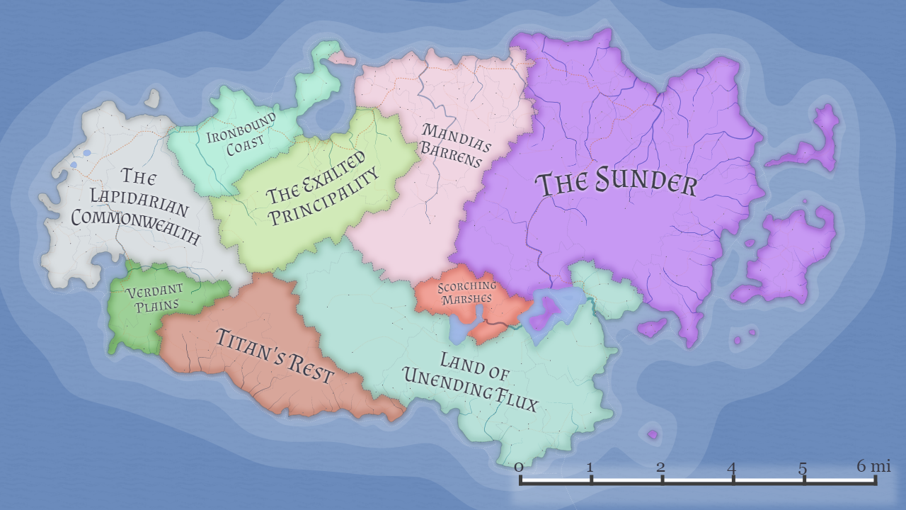

The game takes place in a fully open world fantasy island known as Ewa (pronounced Ee-wah). At its longest point the primary landmass of the game map spans approximately 91 square miles, with the space being split up into 9 distinct areas, each featuring unique geography and unique sets of quests and challenges for the player to complete as they progress through the game.

The difficulty of the game is closely tied with these distinct areas, with the player beginning their journey in the West of the map in the Lapidarian Commonwealth, the easiest overall area in the game in terms of quest requirements, enemy power level scaling and environmental hazards (other than the Verdant Plains, as explained more in 2.2. World Layout and Distinct Biomes). There is some variance in the difficulty within each distinct, but overall, the difficulty of the areas in the game increases the further East the player travels.

The island is primarily rural, with only occasional towns, villages, and nomadic camps scattered across the land. The main exception to this is The Exalted Principality, a land dominated by a large walled off city housing members of high society in huge, gilded towers.

The player will be free to travel through most areas of the surface level of the world from very early on but are encouraged to not venture too far East too early on in the playthrough simply due to the significantly higher difficulty of these further areas.

The land of the game is surrounded by ocean on all sides of the mainland. The player will not be able to traverse too far away from the land of Ewa in this ocean, being prevented by magically infused oceanic storms that will quickly kill the player if they traverse too far out to sea. Should the player wish to traverse to the smaller islands on the East coast of Ewa, they must find some form of transport across the water or study the use of teleportation magic.

## 1.3. Plot Overview

Aeons ago, long before the time of man, the land of Ewa was ruled over by the Śima (pronounced Shee-mah), a highly advanced race of mages, architects, and metallurgists. The study of natural magic and how it could be manipulated for their own purposes drove every aspect of development of this civilisation, including the erection of 5 mighty cities throughout the land that stood within concentrated natural hotspots of magical energy. However as the advancement of the Śima continued, as did their greed as they hungered for more and more powerful magic, power than would not have been obtainable by tapping only into the latent magical energy of Ewa, so they set their studies to the stars to locate a new world far richer in magical energy than their own, in order to pull it closer to them in order to siphon this energy for themselves. The summoning spell used to attract this planet closer to Ewa worked better than they expected however, causing a fragment of the planet to be torn off and collide with the land on the Western coast of Ewa, creating the densely magically concentrated land known by civilisations since as ‘The Sunder’, whilst also scattering thousands of magically charged crystals to be scattered across the whole of Ewa, whilst also killing the entire civilisation of the Śima in the process, leaving only crumbling remains of their once mighty cities in the wake. Alongside the collision of The Sunder into the land of Ewa, a race of ethereal, noncorporeal beings native to the planet that The Sunder was pulled from found their way to Ewa, and since the formation of modern civilisation there has always been hushed rumours that members of this race, referred to as Wisps, are living among us, disguised as regular people to avoid detection, however these rumours say that these creatures can only survive by feeding off praise and worship from others, and therefore even if these creatures did exist would surely no longer be around after this long on Ewa, so these rumours have never been given any basis for becoming anything than a baseless rumour or a story to scare children.

Our story begins thousands of years after these events, beginning in the village of Burg, a humble farming town in the Lapidarian Commonwealth. In this town, the player can visit the humble tavern known as The Weathered Spoon, a seller of wide ranges of unusually low-priced drinks, elixirs and potions ran by the kind yet enigmatic barmaid, Tory. This seems at first like a simple, quaint local tavern to the player at first, but will prove incredibly important to the narrative of the game later through the progression of the game.

Since the extinction of the Śima, the land of Ewa has lived in an uneasy peace, but lately there have been many reports of attacks by magical creatures, great areas of magical corruption spreading throughout isolated areas of the land, and rumours of vicious marauders taking advantage of the panic this corruption has brought to steal, extort, and kill as they see fit. The player character – henceforth referred to simply as The Hero – takes on the task sent from the village elder to see if anything can be done about clearing this magical corruption from the areas surrounding the village, and hopefully return this struggling town to some level of peace.

Word begins to spread across the villages of the land about The Hero and their quest to clear the magical corruption plaguing the land, so more villages begin to reach out, hiring The Hero to tackle the corruption around their towns also. The player continues to gain a reputation amongst the people throughout the land to the point that they gain the attention of the monarch of The Exalted Principality and are asked to enter their gilded city for an audience. Through their actions clearing the magical corruption around various lands of Ewa, The Hero has come to be more knowledgeable with dealing with this corruption than anyone currently under the monarch’s command and is therefore instructed to work with the royal mages to study the corruption and learn of its origins whilst continuing to purge it from the land.

It is through these studies that The Hero learns of the Śima and their inventions and experiments involving unstable magical energies. Through this discovery, you uncover the fact that the largest areas of magical corruption in the world are focused around 5 ancient ruins of vast cities once owned by the Śima, and to clear this corruption The Hero must venture into these cities, both above and below ground, and remove the latent magical energy within these cities that is corrupting the world around them. However, the mages require time to study how The Hero will even be able to enter these blocked off cities in the first place and recommend that in the meantime The Hero travels to the idyllic town of Evergreen to rejuvenate and restock their valuable items and weapons as they study.

The Hero ventures to the town of Evergreen, located in the pristine emerald fields of the land known as the Verdant Plains. When they arrive, they notice there isn’t a single sign of any magical corruption or even any hostile wildlife in the area, and the village seems to be untouched by any negative influence seen throughout the rest of the world. They speak to the town elder, an uncommonly charismatic dwarf by the name of Éatán, who welcomes them and insists they can remain in the town as long as they like. The Hero takes this opportunity to restock vital items and to purchase exotic gear at the town’s various shops and stalls, when inexplicably whilst walking through the town, they come across a location of The Weathered Spoon tavern and notice that inside it is being ran by the same woman as the location in Burg, Tory. She remarks about The Hero’s absence and about all of the horror of the outside world since they have been gone, deeply confusing them as they have only been in Evergreen for a few days.

Unbeknownst to The Hero, the village elder of Evergreen, Éatán, is in fact a member of the aforementioned species of ethereal Wisps and created and is watching over the town of Evergreen in order to receive continuous love and praise from its townspeople to sustain his lifeforce. In order to prolong the time that any individual provides him with this love and worship, Éatán corrupts an individual’s perception of time whilst they are inside the town, therefore keeping them there for significantly longer than they are aware.

For a currently unknown reason, Éatán’s power of time alteration does not affect anyone inside the location of The Weathered Spoon that has just appeared in Evergreen, which allows The Hero to realise that they desperately need to leave this town and see what state the rest of the world has been left in since they have been gone for considerably longer than they had previously thought. When leaving this town, The Hero looks over the surrounding land and notices the entire land has been practically swallowed by the magical corruption that had previously been isolated spots scattered throughout the land. Travelling further out into the lands of Ewa, The Hero finds that it has in fact been multiple years since they left for Evergreen, and without The Hero’s help in dealing with the magical corruption, the kingdoms of the world could not prevent the spread of the corruption, and many lands that once lived peacefully now lived in constant turmoil with the monsters and magically infused villains brought about by these new areas of corruption.

The Hero travels back to The Exalted Principality to try and regroup with the royal mages to find out how they can enter the lost cities of the Śima to hopefully remove the magical corruption from within them to prevent any further spread. As they travel to the city, The Hero notices a faint but unidentifiable object in the sky, far off into space.

Returning to The Exalted Principality, The Hero finds the city in turmoil, with the lower-class citizens of the nation revolting against their monarch due to his lack of action toward dealing with the corruption spreading through the land, with the law enforcement in the city barely capable of keeping any sort of tentative peace between the masses and the city officials. Pushing through this uneasy crowd, The Hero arrives at the palace and travels up to the mage’s tower to determine the results of their research. Here, they find that the monarch of the city has had the mages executed for their lack of progress in dealing with the corruption, but before the mages were taken away, they had left all of their research on the ancient cities of the Śima, their locations, and how to infiltrate them, concealed in the tower in the chance that The Hero should return. Through the prior research of the royal mages, The Hero determines that there are 5 Śima cities throughout the land of Ewa: one located under the great forest of Titan’s Rest, one found deep beneath the ferrous cliffs of The Ironbound Coast, one beneath the everchanging Land of Unending Flux, one which has been partially revealed amongst the sand dunes of the Mandias Barrens, and finally one that now lies beneath the treacherous magical land of The Sunder.

The Hero must travel to these corners of the world. Taking these hidden notes, The Hero ventures out back into the world to discover these lost cities of the Śima, clear the ruins of any dangerous creatures/magical artefacts within, and hopefully prevent any further spread of the magical corruption that is leaking to the surface world due to the latent magical energy being emitted from these now dormant cities.

Venturing out into the world once more, The Hero visits several villages on their way to the first lost Śima city. In their travels, they notice that there is now a location of The Weathered Spoon tavern in every village they visit, which they attribute to growth of the business over the last few years due to more and more people drowning their sorrows about the state of the world in cheap alcohol. However, what cannot be explained is why each location seems to have the same woman behind the counter, the same enigmatic barmaid that they met in Burg and Evergreen, Tory. The Hero cannot begin to explain this, but it does not seem relevant to their quest, so they carry on with their journey.

The Hero slowly makes their way through the various Śima cities, each city taking weeks to traverse due to their sheer scale and the volume of dangerous magical entities and artefacts found within. As they progress through the cities, they notice some inscriptions on the walls of what seem to be various Śima laboratories, telling of their study prior to their destruction of an otherworldly magical entity they referred to only as Grāsakārī (pronounced Grash-car-ee, henceforth known as ‘The Devourer’), which they had discovered to be an impossibly large creature which slowly travels through space, devouring all celestial bodies in its way that have a high concentration of magical potential energy, with the Śima research seeming worried that using the summoning spell that eventually led to the destruction of their civilisation may also alert and anger The Devourer, but their civilisation did not survive for long enough for any of their research on this creature to amount to anything.

The Hero continues to rid the land of large quantities of magical corruption by purifying and decommissioning the dormant Śima cities and the magical artefacts inside, and whilst venturing between the various lands of Ewa to travel between these cities and complete any smaller quests for locals along the way, The Hero notices that overtime the anomaly in the sky continues to grow ever larger, as if something is approaching from far off in space.

As it turns out, the Śima researchers were correct to fear the creature known as The Devourer, and the splitting of The Sunder from its original planet, and the consequent extreme release of magical energy caused by this separation, awoke and attracted this creature, with it being drawn to the remaining fractured planet that The Sunder had split from, which has now been devoured by this creature due to the still very high levels of magical energy throughout the celestial body. When The Sunder was pulled from this planet during the failed Śima summoning spell, as it fell to the surface of Ewa, a trail of latent magical energy was left in its path through space, which has been tracked through space ever since by The Devourer, leading it to Ewa to continue its feast.

By the time The Hero has purged the third Śima city of their quest, The Devourer has made its way into the skies of Ewa, with its presence threatening the existence of the entire land. The Hero must put aside all other goals in their quest to deal with this impossibly large foe. Knowing that it will be impossible to take down such a large opponent by any traditional means, The Hero finds themselves teleporting inside the beast, knowing that the only way to take it down is by completely tearing the creature apart from within. Fighting against warriors formed by the beast out of solid magical energy stored within its vast body, The Hero travels through The Devourer, continuously damaging vital functions of the creature as they progress, until they finally reach its colossal brain. Despite outer appearances, The Devourer is an intelligent creature, and therefore The Hero is given a choice with how to deal with it: reason with it – to prevent it from causing further harm to Ewa but potentially dooming other planets to a similar fate or kill the creature – stopping the creature from hurting anymore planets but potentially massively disrupting the natural cosmic balance of the galaxy due to the elimination of such a prominent predator.

Either way The Hero chooses to go about this, the major threat to Ewa has been dealt with, and due to their efforts across the world and within the lost cities of the Śima, the land can begin to slowly heal, and The Hero is known throughout the land as the champion of Ewa. The game will now end one of two ways, based on how much power and experience the player has built up over the course of the game thus far. Should the player experience level be below a certain threshold, the credits will roll, with the player believing they have defeated the ultimate evil facing Ewa. However, at the end of the credits, a note will appear onscreen, reading “Congratulations on your mighty victory, you should probably go and get a drink…”. Now, either if the player has seen this message, or their power level was high enough to bypass this false final ending, the final arc of the story will play out, all focused on The Weathered Spoon tavern. If the player was below the power threshold and has therefore just seen the credits, this next section will not begin automatically, and they will first have to build up to the appropriate power level in the game and make their way to The Weathered Spoon manually.

As the player may have suspected, there was more than meets the eye in an otherwise innocent establishment beloved throughout Ewa. Should The Hero have gathered enough power throughout their journey, the barmaid that could be inexplicably seen behind the counter of every Weathered Spoon tavern, Tory, will reveal herself to them. Much like the jovial dwarven elder of Evergreen village, Éatán, Tory is too a member of the ethereal magical race known as the Wisps who were brought to Ewa from their home planet during the failed magical summoning spell and subsequent collision of The Sunder into Ewa carried out by the Śima. However, unlike Éatán, who feeds off people’s verbal praise and love to sustain his lifeforce, Tory has spent her life on Ewa sustained through monetary and material tributes and sacrifices as forms of worship. When her homeland first collided with Ewa during the destruction of the Śima, she sought to learn what she could about this now dead civilisation, learning all of their research into The Devourer and in the use and manipulation of natural magic for personal gain. Learning the corrupting power of unstable latent magical energy, she tampered with the remaining magical artefacts within the Śima cities, knowing that the corruption this would spread in the future world would be a perfect way for her to take advantage of the population’s sorrow to generate a significant level of financial and material tributes for her, with the knowledge of the approaching Devourer only acting as an amplifier for people’s sorrow to then drown their sorrows in her service.

She was first in large support of The Hero as their quests throughout the land had brought her significant custom from all walks of life, and to begin with due to the low level of tributes received from the first Weathered Spoon location in Burg, her power levels were incredibly low and therefore standing against The Hero would have been far too great a risk for her. However, as The Hero continued to clear more and more of the magical corruption of the world, less of the population of Ewa felt the need to drown their sorrows, decreasing her custom and therefore her tributes. The turning point however was with The Hero’s defeat of The Devourer. Tory acknowledged that The Hero was too great a threat to not now be dealt with, as they were likely to discover her plot now that the world was saved.

The Hero must now face this once jovial barmaid, now revealed to be an ethereal being of pure magical energy. The difficulty of this encounter will have been determined throughout the course of the game, based on both player experience level, but most importantly how much money they player themself had spent in the various locations of the Weathered Spoon – as more money spent in these taverns throughout the game will mean that Tory has received more personal tribute from The Hero, making her significantly more difficult to defeat as The Hero has unknowingly pledged their tribute to her over the course of the game.

No matter her power level, The Hero must now defeat Tory and prevent her from causing more harm to Ewa. After she is successfully defeated, the player will once again head out into Ewa, ready to heal the land and help its people recover through all of the hardships it has faced.

## 1.4. Gameplay Overview

This game is an open world VR game with significant RPG elements set in a fantasy world called Ewa in which the player character known only as ‘The Hero’ is set the task of cleansing the world of magical corruption and discovering the secrets behind it. The player travels the world interacting with a wide variety of characters and whilst cleansing the corruption also helps to improve the lives of others by doing a variety of tasks for NPCs. The final goal of the game is to beat The Devourer and discover the secrets of the wisps allowing the player to discover the secret boss and remove their control over the general population.

There are two progression systems, one which is locked behind exploration of the world with different weapons and magical runes being placed within the world for the player to discover as they travel with no levelling system blocking use of items but simply that it would be very difficult for the player without being the correct level for the area. The other progression system is a levelling system which allows the player to raise their maximum health, mana, defence and strength. The first encourages the player to explore the world and not just stick to the main path whereas the second limits the player slightly by encouraging them to explore the easier regions first and to stay on level with the area they are in but also helps the player to understand roughly when they should be in an area as due to the open world there is very few physical barriers blocking players from going straight to later game areas immediately. The previously mentioned combat and magic systems are fluid and can be used together in combat allowing the player a choice of how they want to tackle the game challenges and with what tools they want to use to do so. This is yet another aspect that encourages exploration as the player starts with almost no weapons and very basic magic but through exploration of the game world, they are able to gather powerful weapons and more runes to use in spells. There is no crafting system as all items can be bought from NPCs or gathered from the world such as arrows from enemy camps.

## 1.5. Visual Design and Aesthetics

1.5.1. General Aesthetic

The game world takes on a low poly but high-fidelity appearance, similar to games such as Valheim and Deep Rock Galactic where the majority of objects and the game world itself are made of far less polygons than a realistic model but with detail in the textures and effects.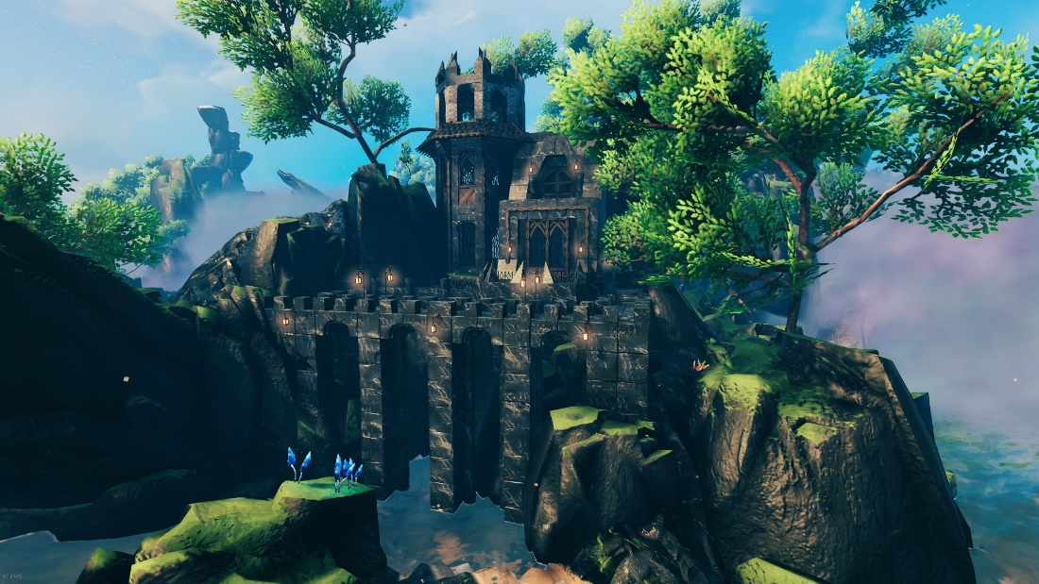(Valheim, Iron Gate Studios, 2021)

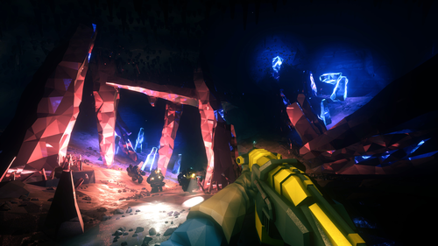(Deep Rock Galactic, Ghost Ship Games, 2020)

### 1.5.2. The Sunder’s Crystal Glow

The Sunder is a chunk of another ancient world that has been brought down into the world in which the majority of this game takes place, as the player gets closer to this part of the map, they will encounter little fragments of the land broken off and scattered. Whilst exploring The Sunder, the player will notice the numerous crystals embedded in the land. The ground, the hills, the trees – little escapes the magical light of these tiny crystals. The flora and fauna of this land though appearing to be somewhat ordinary from a distance are also embedded with these crystals, the ‘petals’ of what may seem at a glance to be flowers and the ‘eyes’ of some creatures.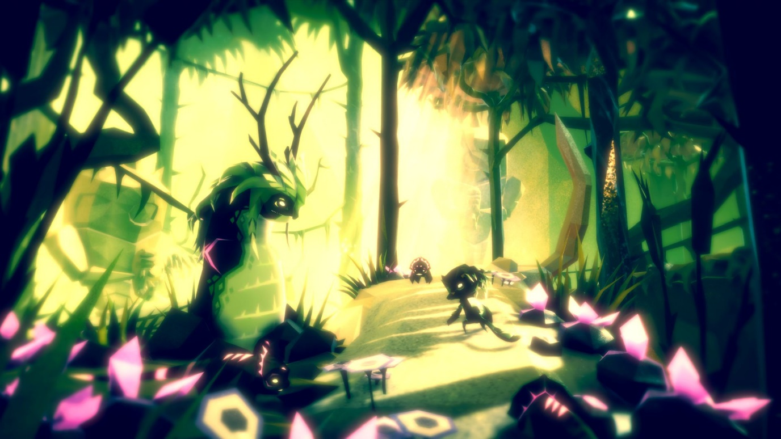(Fe, Zoink, 2018)

## 1.6. Interface Design

1.6.1. HUD

There are two versions of the Heads-Up Display, one optimised for flatscreen gaming and another for Virtual Reality Head Mounted Displays.

#### 1.6.1.1. Flatscreen HUD

The more standard flatscreen HUD contains elements such as the Health, Mana, and Experience/Level Bars, all of which will be visible only when they are in use. For example, when full, the HP bar fades out of view, but pops back in as soon as the player takes damage and will stay on screen if the players HP is low (>20%) as a reminder to restore HP. The Mana bar works the same way as the HP bar. The level and experience bar are shown whenever the player gains experience points and fade out 2 seconds later.

When the players HP and Mana are low their respective HUD elements will blink lightly with a slow pulse effect behind them once every 2 seconds., making them visible but not too distracting.

#### 1.6.1.2. Virtual Reality/HMD HUD

The VR/HMD HUD is similar to the flatscreen HUD but with a few additions for immersion. The device on the players’ wrist – similar to a Pip-Boy from the Fallout franchise – will display the players stats whenever it is in view. The player’s view will also turn slightly red when on low health instead of keeping the health bar on screen.

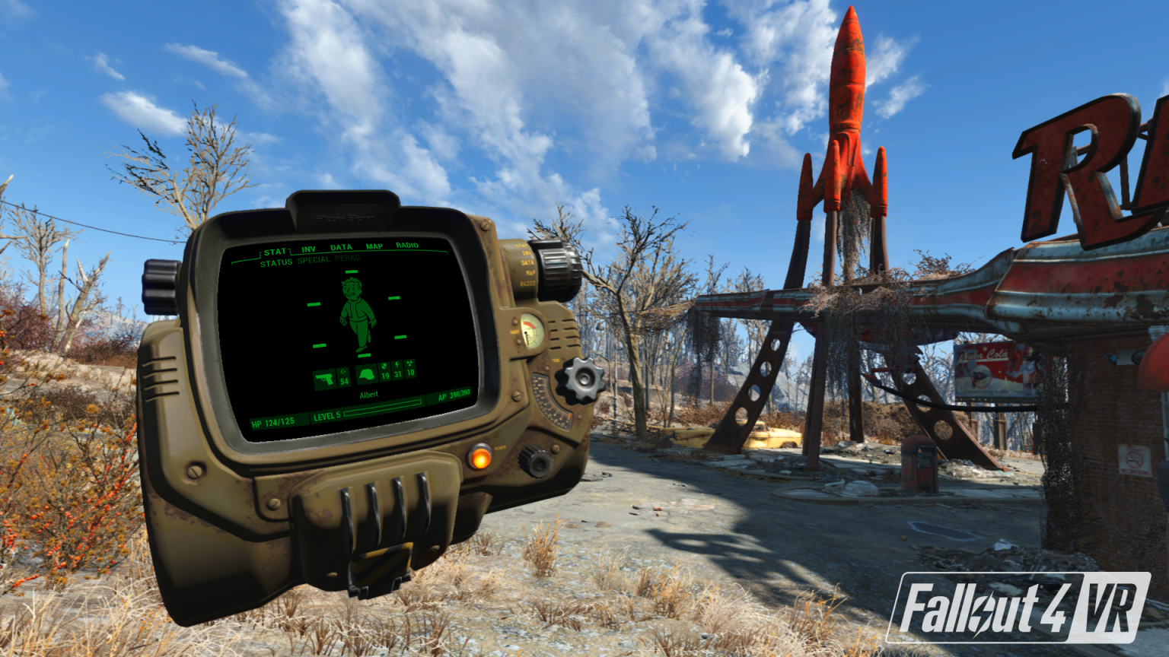(Fallout 4 VR, Bethesda Game Studios, 2017)

1.6.2. Menus

As with the HUD, menus work slightly differently dependant on the players’ hardware.

1.6.2.1. Flatscreen Menus

The menu takes on the appearance of a slightly worn adventurer’s logbook, each menu taking up a page. Inspired by the Wondrous Tails journal in Final Fantasy XIV (Square Enix, 2013).

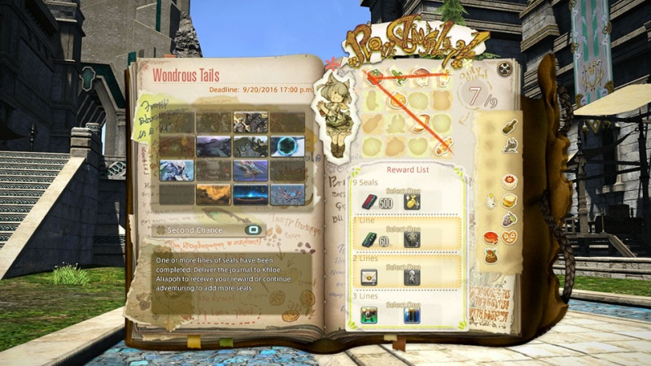(Final Fantasy XIV: A Realm Reborn, Square Enix, 2013)

1.6.2.2. Virtual Reality/HMD Menus

The VR/HMD menus are more interactive than their flatscreen counterparts, to enter the menu the player reaches to behind their hips or over their shoulders – as set in the options – to grab their adventuring logbook. This book automatically opens as it reaches the player’s view, displaying the main menu. Players can navigate this menu in whichever way is comfortable for them, either by pointing and selecting using the laser pointer on the controller or by physically making the motion of turning the page from any of its corners.

1.6.3. Controls

Keyboard and Mouse

|  |  |
| --- | --- |
| KEY | ACTION |
| W, A, S, D | Move Directionally - Forward, Left, Backward, Right - Respectively |
| SPACE | Jump |
| ESCAPE | Open menu |
| RMB | Block |
| LMB | Attack/Select/Draw/Cast |
| ALT | Bring up Rune Drawer |
| CTRL, C | Crouch |
| LShift | Sprint |
| F | Interact |

#### Virtual Reality Controller (Valve Knuckles use as example)

In VR, many controls are moved from button inputs to gestures. Attacking is done by physically swinging your weapon and looking around is done by physically moving your head.

|  |  |
| --- | --- |
| BUTTON | ACTION |
| Right A | Jump |
| Right Trackpad (Hold) | Bring up Rune Drawer |
| Right Trigger | Cast |
| Right/Left Grip | Pickup |
| Left A | Interact |

## 1.7. Mission Structure

Missions fit into three categories that can be summarised as corruption cleansing, NPC tasks and dungeon clearing with each having varied mission styles but ultimately being summarised by these descriptions. Corruption cleansing is the primary goal of the player character as they progress throughout the game clearing magical corruption wherever it is found. This mission style will consist of the player adventuring to a new area they have yet to explore and clearing the enemies of that area and then containing the magic. This is often where bosses will be placed as the final protector at the centre of the magical corruption of an area who will need to be defeated before the player is able to contain the magic.

NPC tasks are smaller missions that can be taken as the character is exploring the world and will often consist of one of the following mission types:

Item Recovery

Item Delivery

Area clearing of enemies

Message relaying

and legendary item hunting

These will be available from NPCs in both settlements, often inside the weathered spoon, and from characters on the road as the player travels between major objectives.

Finally, dungeon clearing is a more advanced version of the NPC task to clear an area of enemies often triggered by the character entering either a cave or catacomb that is not magically corrupted but is filled instead with hostile enemies. These are often where new weaponry or runes can be found for the player, encouraging exploration of the world. As the game progresses often these missions will overlap with dungeons containing magical corruption but not being required for progression through the main storyline and NPCs asking the player to clear a dungeon and recover an item for them.

# 2. Game World and Environment

## 2.1. World Size

The primary map of Ewa spans approximately 95 square miles, putting it similar to the open world size of The Witcher 3: Wild Hunt (CD Projekt Red, 2015). The world is split up into 9 distinct regions of varying size, layout, environmental styles, and unique locations to explore. Primarily the quests unique to a given area will have the player remain in that singular area until completion of the quest, but the main questline will have the player travelling throughout all of the various regions throughout its course.

The player will be free to explore most of the regions of the game from very early on, however due to the hugely changing geography and topography between many of these regions (for instance multiple areas featuring large unscalable mountains), the player will be softly prevented from travelling between certain regions without visiting others down their current path.

Also acting as a natural form of player containment is the sheer size of the world. For comparison, the open world map featured in Elder Scrolls V: Skyrim (Bethesda Game Studios, 2011) spans about 15 square miles, so the significantly larger size of each region in this game will encourage players to explore more of their surrounding region before moving on to the next. To also add to this incentive, the player will be able to fast travel between select waypoints in the world when not in combat however a waypoint in a given location will only become available for use when the player has cleared the area surrounding the waypoint of corruption, further incentivising the player to explore more of their surrounding area before progressing.

The game will feature 5 primary ‘dungeons’ in the form of 5 ruins of the ancient cities of the Śima. Due to the small number of these cities, they will be significantly larger than a standard dungeon in most fantasy games, therefore taking far longer to traverse and complete than a standard RPG fantasy dungeon. Due to this, the player will not be expected to complete these dungeons beginning to end in a single play-through. Instead, the player will be expected to progress through a certain portion of the dungeon before reaching a checkpoint, where they will then return to the overworld, only returning to complete the next section of the dungeon once other requisites in the world have been completed (e.g., the player has gathered a specific required item from a quest on the surface in order to open a previously impassable door in the dungeon).

## 2.2. World Layout and Distinct Biomes

### 2.2.1. The Lapidarian Commonwealth

The Lapidarian Commonwealth acts as the starting point on the player’s journey through Ewa. The land of this region consists of harsh, rocky terrain and pounding waterfalls, with small stretches of fertile land in which small human villages have settled. The player begins their quest in the quaint walled farming village of Burg, a town consisting of simple wood and stone homes, small stretches of farmland, and a cosy tavern known as the Weathered Spoon.

#### 2.2.1.1. The Weathered Spoon

As laid out in 1.3. Plot Overview, The Weathered Spoon becomes incredibly important during the conclusion of the game’s plot, and the first location of this important tavern can be found here. It’s quaint tavern beloved by the locals of Burg, a quaint stone and wooden building with very simple seating, cosy fireplaces, and exotic décor adorning the walls from all corners of Ewa. When asked about how she acquired any of these items, the barmaid, Tory, claims they were souvenirs from her ‘travels’ when she was younger despite seeming very young still, but her usual clients are normally far too drunk on her cheap wares to ever question it, particularly as many customers have noted they feel a compulsion to continue to spend more and more whenever they are inside the tavern.

### 2.2.2. Verdant Plains

To the Southwest of the map lies a beautiful, idyllic landscape known as the Verdant Plains. This area acts as a deeply important location after a few hours of progression into the main plotline. Once the player has progressed to this point in the campaign, they will be given a questline telling them to travel to the Verdant Plains and locate the village of Evergreen, a place said to be completely untouched by the corruption of the world, in order to understand what force is preventing the evil from touching the land around this area. When the player arrives, they are met with rolling hills and vast, lush green plains, with the quaint village of Evergreen standing in the centre. Outside of this village there is not much to see in this land outside of the lush green hills, but the area is ideal for collecting many natural flora resources as it is a hotspot for the growth of medicinal and alchemical herbs that can be used for potion brewing by the player.

#### 2.2.2.1. The Village of Evergreen

This area will act as a point of levity for the player, allowing them to relax after the challenges they have faced up to this point, to buy exotic items and sell the valuables they have accumulated thus far. Within the town there are multiple unique vendors selling unusual wares, the likes of which the player would be unable to find elsewhere in the game. This includes a seller who sells books written in a long dead language, a blacksmith that specialises in using incredibly old, traditional techniques to produce styles of weapons that had not been popularly used for thousands of years, and a tailor who crafts incredibly ornate, strong armours out of very unorthodox materials and in styles that faded into obscurity lifetimes ago.

However, the player will at first be unaware that things are not in fact what they seem in this village, for whilst the player may have only spent a short amount of time in this village, time outside the valley has in fact passed by years, and without its hero, the world’s corruption has spread exponentially, with this evil becoming far stronger and enveloping every corner of the world outside of Evergreen.

The protagonist will only be made aware that time may not be moving as they perceive after, at one point during the player’s visit to the village, a branch of The Weathered Spoon tavern opens in Evergreen, somehow with the same barmaid running the shop as the previous shop. Whilst inside this tavern, time begins to flow as it normally would outside of the town, and the barmaid begins questioning the protagonist on where they have been, prompting the revelation.

### 2.2.3. The Exalted Principality

The Exalted Principality is a fairly flat area of simple green plains, which is entirely dominated by a grand, opulent city in which all members of human high society reside. The city is the political centre of the modern world, and features the most elaborate, rich architecture and decor in the entire land of Ewa. The player will visit this area after being summoned by the monarch of the city to work with the royal mages in order to try and determine the origin of the magical corruption that has been spreading through the land, and will be able to train in many forms of magic with the royal mages as well as find many vendors selling incredibly up-market, highly priced exotic goods from unique weapons and armour to expensive and unusual potions.

### 2.2.3. The Ironbound Coast

The Ironbound Coast is an area on the Northwest coast of Ewa known for dense, ferrous terrain. Due to the high concentration of valuable natural resources, in particular large deposits of precious metals and minerals, this area is the primary area of surface land across Ewa that is favoured by the dwarves due to their highly advanced mineral extraction and mining techniques. The area as a whole is of minimal danger, however the high concentration of surface-level metals in the terrain causes this area to be at very high-risk during lightning storms, and many hostile creatures that may usually be only found below the surface may be found wandering the coast here, using the dwarven mining tunnels to emerge from their underground dwellings. Unbeknownst to the dwarves residing in this area, below the surface of the great metallic cliffs of The Ironbound Coast also lies one of the five ancient cities of the Śima, known as Śakti – The City of Energy.

#### 2.2.3.1. Śakti – The City of Energy

This is one of the three cities required to be completed by the player in order to progress the main narrative of the game. The Śima built this city within the metallic cliffs of The Ironbound Coast to take advantage of the frequent powerful lightning storms that will hit this land, as they could capture the energy from these storms to use as a basis for much of their civilisation’s magical studies – in particular into the study of the effects of the combination and fusing of various elemental magics, as well as to power the creation of many magical artefacts and magically infused weapons, tools, and technology. Because of this, this city features high levels of mechanical defences and energy-based traps which should be dealt with carefully by the player as they progress through the city whilst destroying all threats, looting any worthwhile valuables, and removing all sources of magical corruption they can find.

### 2.2.5. Mandias Barrens

The Mandias Barrens are a vast wasteland of scorched earth with very little foliage able to survive in the area. During the reign of the Śima this land acted as the centre of their civilisation, acting as the location of their capital city known as Ālō – The City of Light. Due to its proximity to the area of land where The Sunder collided during their failed summoning ritual, this once bountiful land was incinerated beyond repair, leaving only crumbling remains of the once mighty structures of the Śima scattered amongst the sprawling sand dunes. Additionally, due to this land being in direct contact with the magical Sunder, the land is infused with powerful latent magical energy, causing freak extreme weather and magically infused storms. This on top of the bands of lawless marauders and feral magical creatures that now call this land home makes the Mandias Barrens an incredibly deadly area that should be avoided by all but highly experienced adventurers.

#### 2.2.5.1. Ālō – The City of Light

This is one of the three cities required to be completed by the player in order to progress the main narrative of the game. During the time of the Śima, Ālō served as the capital city of their empire, serving as the proud display of the power of the Śima, viewable across all of Ewa. It featured grand, impossibly tall buildings and statues constructed and maintained using magic and was the only Śima city to be almost entirely above ground. This proved to be this city’s major downfall however, as it was significantly more exposed to the destruction caused by the collision of The Sunder into the land of Ewa, tearing down the once mighty structures of the city and leaving only rubble and a few semi-intact structures scattered through the newly scorched desert sands of the Mandias Barrens. Due to the nature of the city being above ground and certain structures still remaining partially intact, these city ruins have now found themselves home to gangs of marauders and predatory animals alike, so whilst this may be the least dangerous Śima city overall, massively due to the hubris of the Śima as they did not install any form of major security systems into their capital city – magical or otherwise – players should still maintain caution as there are many natural dangers that still await them in the ruins of Ālō, and it is very unclear how long the still standing structures of the city will remain that way.

### 2.2.6. Titan’s Rest

The land of Titan’s Rest consists of a large bountiful forest land featuring impossibly large trees with deep, red bark that have stood unchanged throughout all of recorded time. This land serves as the home of the elven kingdom, a series of elaborate yet rustic treehouses connected by conjoining walkways. The name of the land is derived from ancient elven mythology focused on the trees in this land, which were said to stand so uncommonly tall and strong as they were in fact sleeping gods that would one day reawaken. The truth of the fact however is that these trees stand so unnaturally tall as below this land lies one of the fallen cities of the Śima known as Prakr̥ti – The City of Nature, which to this day holds many magical artefacts and pieces of machinery that have gone unused for millennia, and therefore the latent magical energy of these items has slowly risen to the surface, being absorbed by the plant life of the land, also causing certain native animal species to grow unnaturally large due to their consumption of this magically infused flora.

#### 2.2.6.1. Prakr̥ti – The City of Nature

This is one of the three cities required to be completed by the player in order to progress the main narrative of the game. This city acted as the area in which the Śima studied all things to do with the natural world, from the naturally occurring magical energy of Ewa – which has long since been all but extinguished by their studies, with the significantly more prominent forms of magic in the world today all coming from the magical energies spread through the world by the collision of The Sunder – to the study of the naturally occurring flora and fauna of Ewa, and how the plants and creatures of the world interacted with this natural magic through their creation of various magical artefacts and instruments that they tested on various animals of the land. Due to their experimentation on the plants and animals of the land within the walls of this city, this has resulted in deeply mutated creatures that still remain alive throughout the city alongside hostile mutated plants that seem to have been given some form of intelligence through the experiments carried out by the Śima. The player should be deeply cautious when traversing this city, as the magically infused animals within its walls are incredibly dangerous but will generally not attack unless provoked, and many riches and much knowledge of the natural world of Ewa can be gained by the player should they make it through the city alive.

### 2.2.7. Scorching Marshes

The Scorching Marshes are a treacherous swampland featuring heavily saturated wet grounds and deep bogs home to many dangerous natural and magical creatures. It gets its name due to its proximity to the magical land of The Sunder, as the land was set ablaze during the collision of The Sunder with Ewa, and due to that lands magical influence, those fires have yet to extinguish even to this day, making traversal extremely perilous. Adventurers should only explore this area if they are already a highly experienced combatant and are proficient in techniques effective in attacking/defending against fire and flame-based attack.

### 2.2.8. Land of Unending Flux

Since the fall of the Śima, the Land of Unending Flux has remained completely untamed and without any organised civilisation residing in this land. This is due to the location of the land, being in the centre of Titan’s Rest – the forest realm of the elves, The Exalted Principality – the bountiful human capital, the Mandias Barrens – a harsh desert wasteland, the Scorching Marshes – a treacherous burning swamp, and The Sunder – an incredibly unstable alien land of intense magic. Due to the extreme variance of all of the lands surrounding it, the Land of Unending Flux is under constant natural and unnatural turmoil, ultimately rendering this area a natural No Man’s Land, unable to be permanently settled due to how much its landscape changes, being constantly regrown and destroyed in many different ways due to the clashing of the surrounding lands. This land is home to one of the ancient lost cities of the Śima known as Dhana – The City of Wealth.

#### 2.2.8.1. Dhana – The City of Wealth

This is one of the two optional Śima cities, that do not need to be completed by the player to progress the main story but can be completed in their own time and will provide a significantly higher challenge level to the player in exchange for rare, high-level rewards and items as well as a large amount of experience points upon completion of the city.

This city served as the financial capital of the Śima empire, acting almost as a city sized bank for all of the wealth accumulated by the civilisation as a whole. Due to this, this city features the most extravagant, pompous architecture of any Śima city, as well as a deeply intricate security system throughout all of its layers. Infiltrating this city to remove all magical corruption within will function similar to a heist, with the player being required to carefully plan their movement throughout the city to avoid detection by various elements of the city-wide security system, solving many intricate puzzles along the way in order to unlock elements of the area to progress deeper into the city. Unlike many of the other challenges in the world, this city cannot be completed by sheer brute force, and must be completed stealthily and thoughtfully, as detection by some of the aspects of the city’s security system would make further progression into some of the key areas of the city impossible until the player leaves the city, therefore resetting the security system. Due to the heavy puzzle solving elements found throughout this city, this city will operate the most like a traditional dungeon found within games such as The Legend of Zelda franchise by Nintendo, with the added challenge of maintaining stealthy gameplay throughout. Due to the unique challenge of this city compared to the rest of the game as well as the in-universe context of how the Śima used this city, completion of the city will yield extremely high value rewards, including entirely unique weapons, armour, and very large amounts of in-game currency.

### 2.2.9. The Sunder

This is the most challenging and varied area of the game world. The Sunder is a fragment of an alien world that was broken apart by the Śima during a failed summoning spell which collided with the land of Ewa, destroying all civilised life in the land at the time. This planetary fragment is incredibly rich in magical energy and is the origin of all of the magical crystals that are now scattered throughout all of the lands of Ewa. The landscape of this area is coated in purple light, with all of the flora in this area emanating a soft glow, adding to the deeply mystical feeling of this area.

The Sunder is not home to any civilised life but is teeming with magical creatures the likes of which would not be found throughout the rest of Ewa, as well as extreme, crystalline geology and landscape. This land is significantly more dangerous than the other areas explorable in Ewa due to the unstable natural magic sources throughout the entire land that provide a wide range of potentially lethal environmental hazards as well as the high variety if vicious magical creatures found throughout the land.

Beneath The Sunder, sunken below ground by this magical land as it fell to Ewa, is one of the lost cities of the Śima known as Andhakāra – The City of Darkness.

#### 2.2.9.1. Andhakāra – The City of Darkness

This is one of the two optional Śima cities, that do not need to be completed by the player to progress the main story but can be completed in their own time and will provide a significantly higher challenge level to the player in exchange for rare, high-level rewards and items as well as a large amount of experience points upon completion of the city.

This city acted as a direct counterpoint to Ālō – The City of Light, in that it is the location designated by the Śima to conduct their darkest, most unnatural and destructive magical experimentation, out of sight of their regular civilisation. To emphasise the black-ops nature of the work carried out in this city, the Śima also refused to place any traditional lighting systems throughout the majority of the city, believing that anyone who is not already aware of the horrors carried out in this city and is therefore not already equipped with appropriate equipment to allow them to see through the darkness should not be allowed to view the perverse experiments taking place here. Due to this philosophy, whilst traversing this city, the player must at all times carry a source of personal light if they wish to be able to see more than a few inches in front of them within most of this buried city ruin. However, this will also prevent the player from utilising both hands for combat or puzzle solving, and they will therefore occasionally be required to choose between full control of their both hands for combat and puzzle solving and maintaining a reasonable field of view of the space around them in the city. Due to this struggle, the player must keep their wits about them at all times whilst inside the depths of this city, particularly as this city now lies beneath The Sunder, and much of the latent magical energy of the area has flowed down into the halls of this city, infusing the incredibly dark, dangerous experiments held within with significantly more magical power, making the horrors that the player will face in this city some of the toughest physical and mental challenges of their journey, particularly as many of these will be appearing out of total darkness as the player continues to juggle their required magic/items whilst trying to light their way through the city.

### 2.2.10. Lost Cities of the Śima

The ruins of the ancient cities of the Śima civilisation will function as the primary dungeons for the player to explore. The game will feature five of these cities in total scattered throughout the world both above and below ground, with 3 of the cities being required to be completed by the player to progress the main narrative of the game, and the other two functioning as optional challenges with significantly increased difficulty for the player to complete in their own time should they wish, with significantly greater rewards for the player should they complete these two final cities. The gameplay styles and recommended traversal styles of the areas vary between city, with some areas requiring confident brute force to progress through, some requiring a quieter, more stealthy approach, and others requiring a more thoughtful progression as the player must complete a series of challenging puzzles to progress rather than worry about fighting as much.

## 2.3. Location Aesthetic Inspiration

### 2.3.1. The Lapidarian Commonwealth

The Lapidarian Commonwealth draws much of its environmental inspiration from various dense, rocky areas found around England, in particular the area of High Force in County Durham due to its impressive waterfalls, and Gordale Scar in North Yorkshire due to its steep, rocky terrain and its natural, rural beauty.

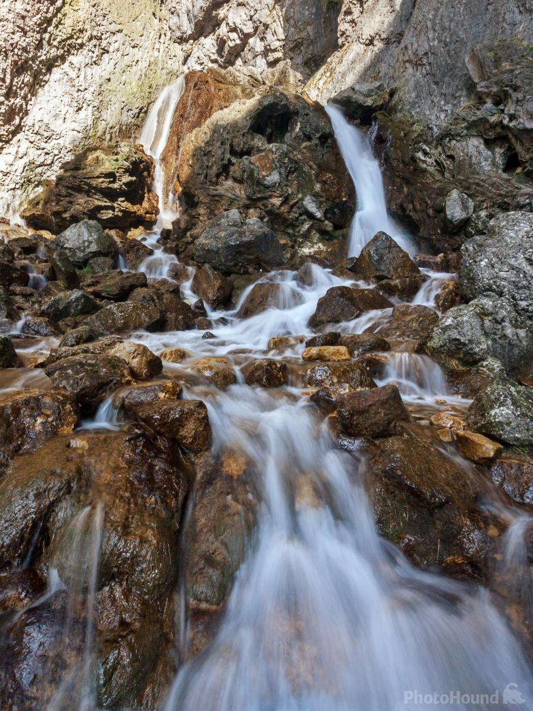

(Robinson, 2016)

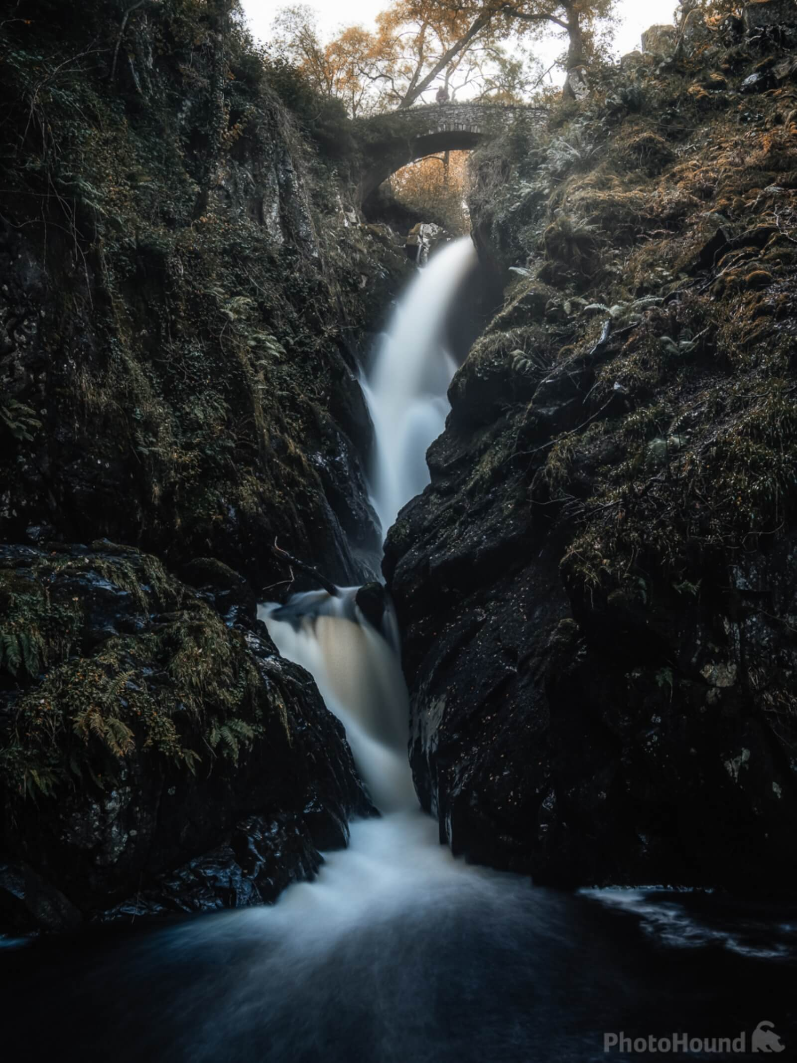

(Billings, 2020)

### 2.3.2. Verdant Plains

To the Southwest of the map lies a beautiful valley, untouched by the corruption of the world, housing a small but bountiful village known as Evergreen. This entire area of land seems entirely idyllic, with not a single mark of the magical corruption facing the rest of the world being seen here. This area takes much of its visual inspiration from the Yorkshire Dales, particularly focusing on the valley of Swaledale, with its rolling green hills and large sprawling fields of greenery.

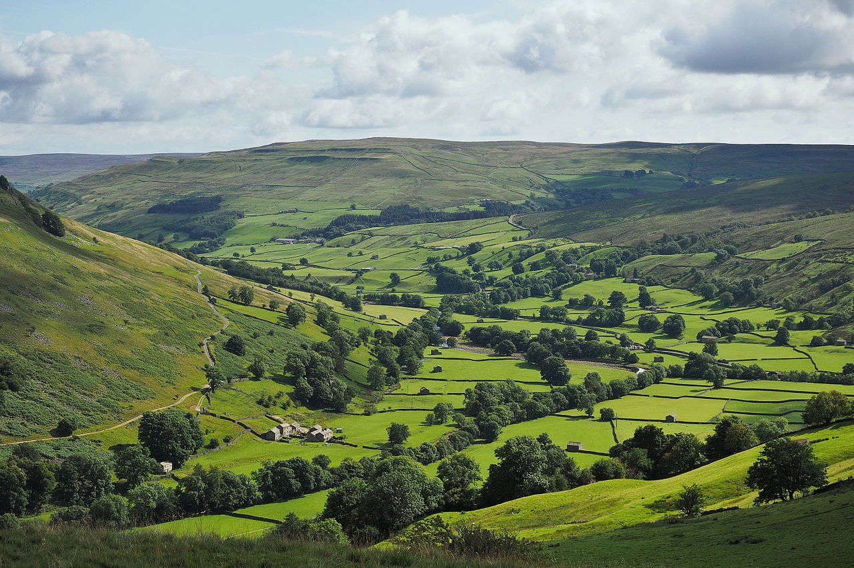

(Kreuzschnabel, 2015)

#### 2.3.2.1. The Village of Evergreen

The village takes visual design inspiration from various fantasy towns and villages that feature a large number of natural spaces, blending the man-made structures with the natural world rather than enveloping it. Some notable design inspirations from various existing media include Kakariko Village as featured in The Legend of Zelda: Breath of the Wild (Nintendo, 2017), as well as the design used for Hobbiton in the first Lord of the Rings film (The Lord of the Rings: Fellowship of the Ring, 2001).

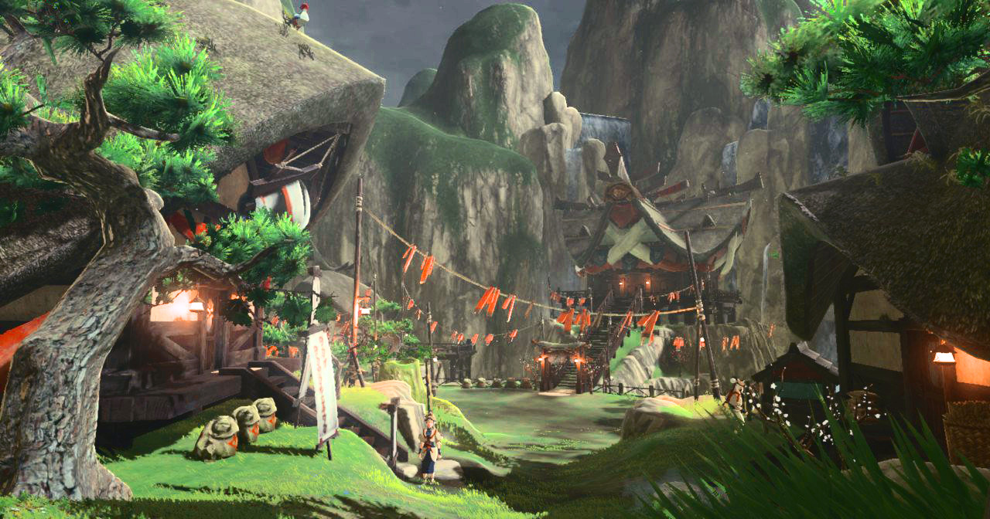

(Kakariko Village, Legend of Zelda: Breath of the Wild, Nintendo, 2017)

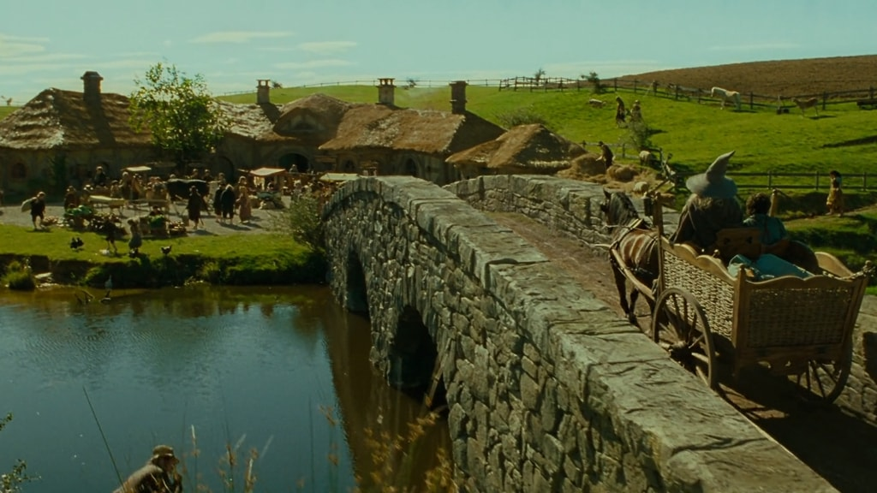

(Hobbiton, The Lord of the Rings: Fellowship of the Ring, 2001)

Design inspiration has been taken from these two locations due to their pseudo archaic designs and the prominent interplay between the natural environment in these two towns, which were a perfect visual inspiration for the harmonious nature I wanted to convey in the design for Evergreen, with the town being an idyllic, almost unnaturally serene location untouched by the pain and corruption in the rest of the world.

### 2.3.3. The Exalted Principality

The Exalted Principality is dominated by a grand, ornate city featuring exaggerated, larger-than-life architecture. The design of this city is primarily inspired by the designs of three grand cities from the high fantasy franchises The Elder Scrolls, Dragon Age, and The Lord of the Rings. The first inspiration is The Imperial City of Cyrodiil as featured in The Elder Scrolls IV: Oblivion (Bethesda Game Studios, 2006), due to the strong walled-off architecture of the city and the sheer height of the central spire as a clear, arrogant display of power and superiority over the surrounding land.

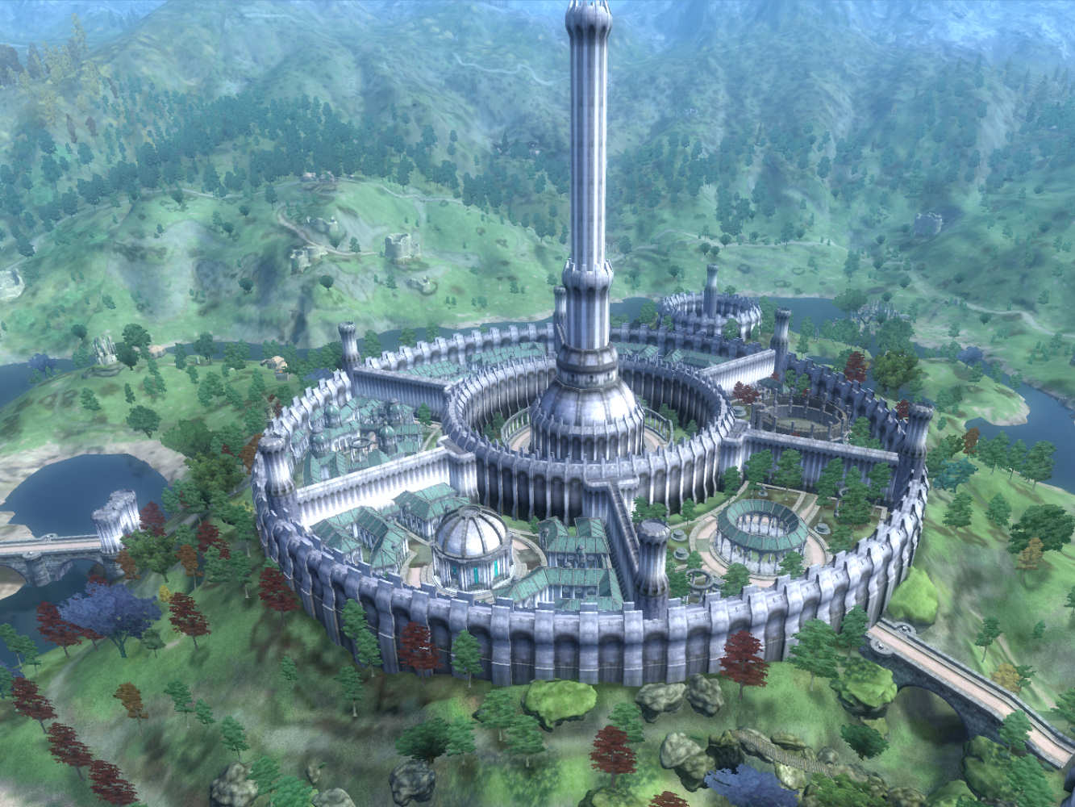

(Cyrodiil, Elder Scrolls IV: Oblivion, Bethesda Game Studios, 2006)

The next point of inspiration is the city of Val Royeaux, as featured in Dragon Age: Inquisition (Bioware, 2015), due to the consistent use of rich, gilded architecture and heavy use of royal colours and architectural details used throughout the city as a clear flaunting of the wealth of the city, an idea that would be perfect to be carried over to this grand city.

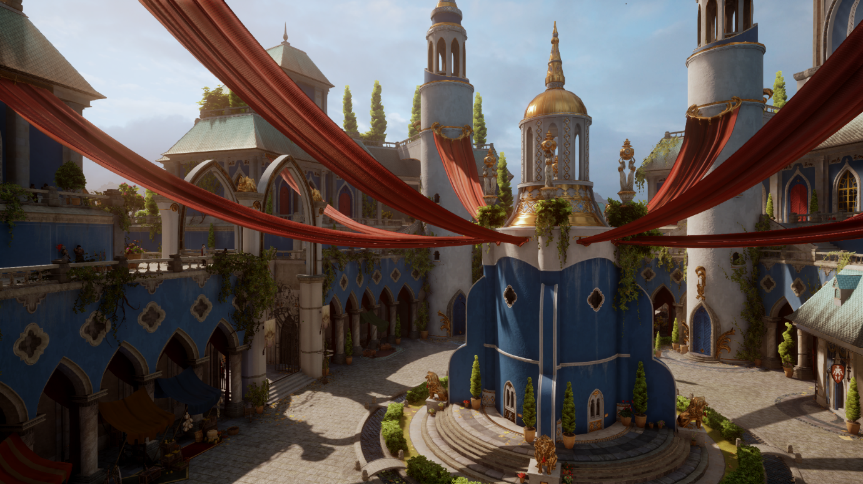

(Val Royeaux, Dragon Age: Inquisition, Bioware, 2015)

The final primary source of aesthetic inspiration for this area is the city of Númenor, as featured in The Lord of the Rings: The Rings of Power (Amazon Studios, 2022). This is due to the fact of how that city is shown to completely dominate and devour the entire natural land around it, and despite looking proud and strong, the city itself is barely holding together, and the hubris of its leaders may soon be its downfall. This idea of a grand, proud city that may in-fact only be a façade was a large inspiration for the concepts of the city dominating The Exalted Principality.

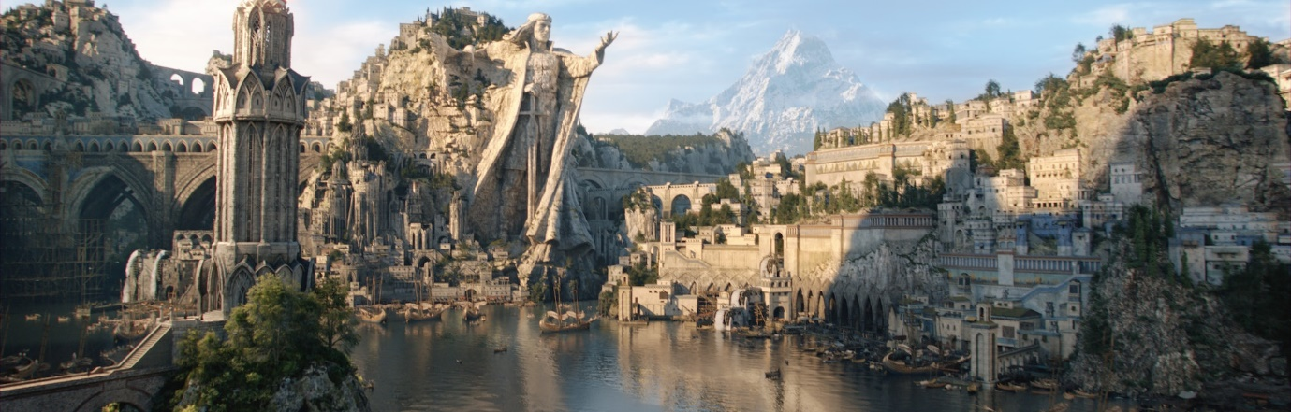

(Lord of the Rings: The Rings of Power, 2022)

### 2.3.4. The Ironbound Coast

The Ironbound Coast derives much of its visual inspiration from the open world area of The Storm Coast as featured in Dragon Age: Inquisition, due to its perpetually rain-soaked terrain and large stretches of rough, rocky coastline.

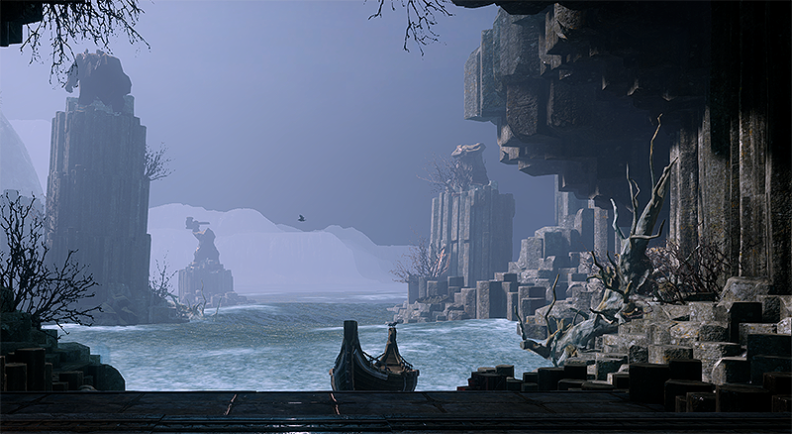

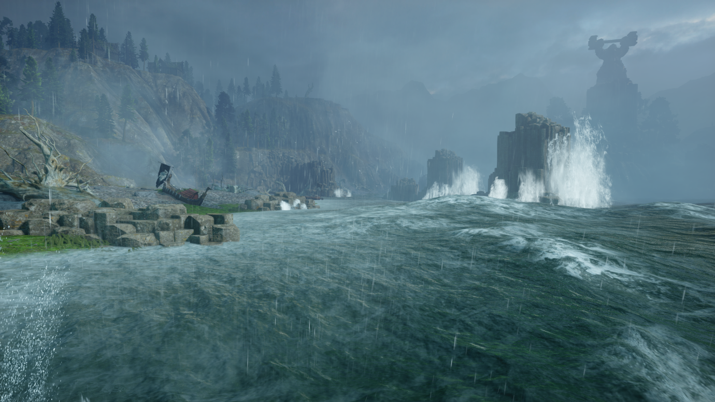

(Storm Coast, Dragon Age: Inquisition, Bioware, 2015)

### 2.3.5. Mandias Barrens

The Mandias Barrens are a vast wasteland comprised entirely of arid, dried desert with very minimal vegetation or natural fauna, with an ever-present lingering magical aura in the area due to its proximity to The Sunder. Design inspiration for this area is taken largely from the open world desert wasteland featured in the game Mad Max (Avalanche Studios, 2015) due to the extremely dangerous sand covered terrain and volatile abnormal weather patterns, in this case caused by magical interference with the weather due to the location’s adjacency to The Sunder.

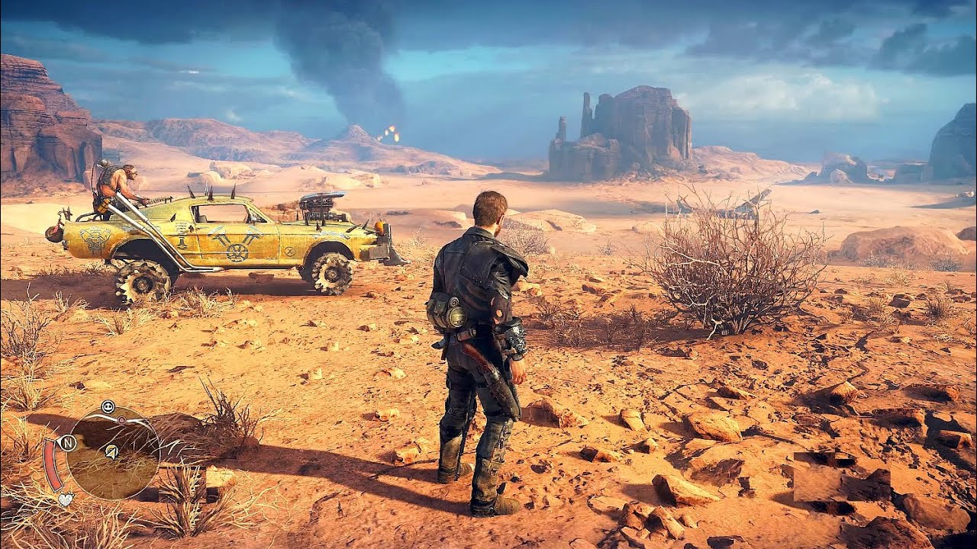

(Mad Max, Avalanche Studios, 2015)

In addition to this, the area takes inspiration from the classic sonnet Ozymandias (Shelley, 1818), which describes the decimated ruins of a once mighty empire that are discovered in a desert by a traveller. This was a large inspiration for this area due to the fact that the greatest city of the Śima once stood here due to its central location on the island, and due to their hubris in causing The Sunder to collide with Ewa, their once mighty city now stands in ruins, much as how Shelley describes the statue of Ozymandias lying in ruins in his sonnet.

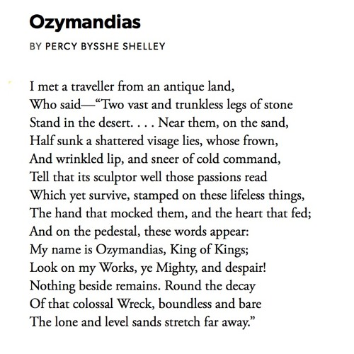

(Ozymandias, Percy Bysshe Shelley, 1818)

### 2.3.6. Titan’s Rest

The primary inspiration for the visuals of the area of Titan’s Rest is the Redwood National Parks found in Northern California. These parks are home to red-hued trees that grow to incredible heights and maintain very dense foliage all year round. This area acts as the home of the elven kingdom of Ewa, but to distinguish this from comparable kingdoms of elves in popular fantasy media, the Redwood National Parks were chosen as a point of reference to give the place a more rustic, down-to-earth atmosphere to the elven kingdom.

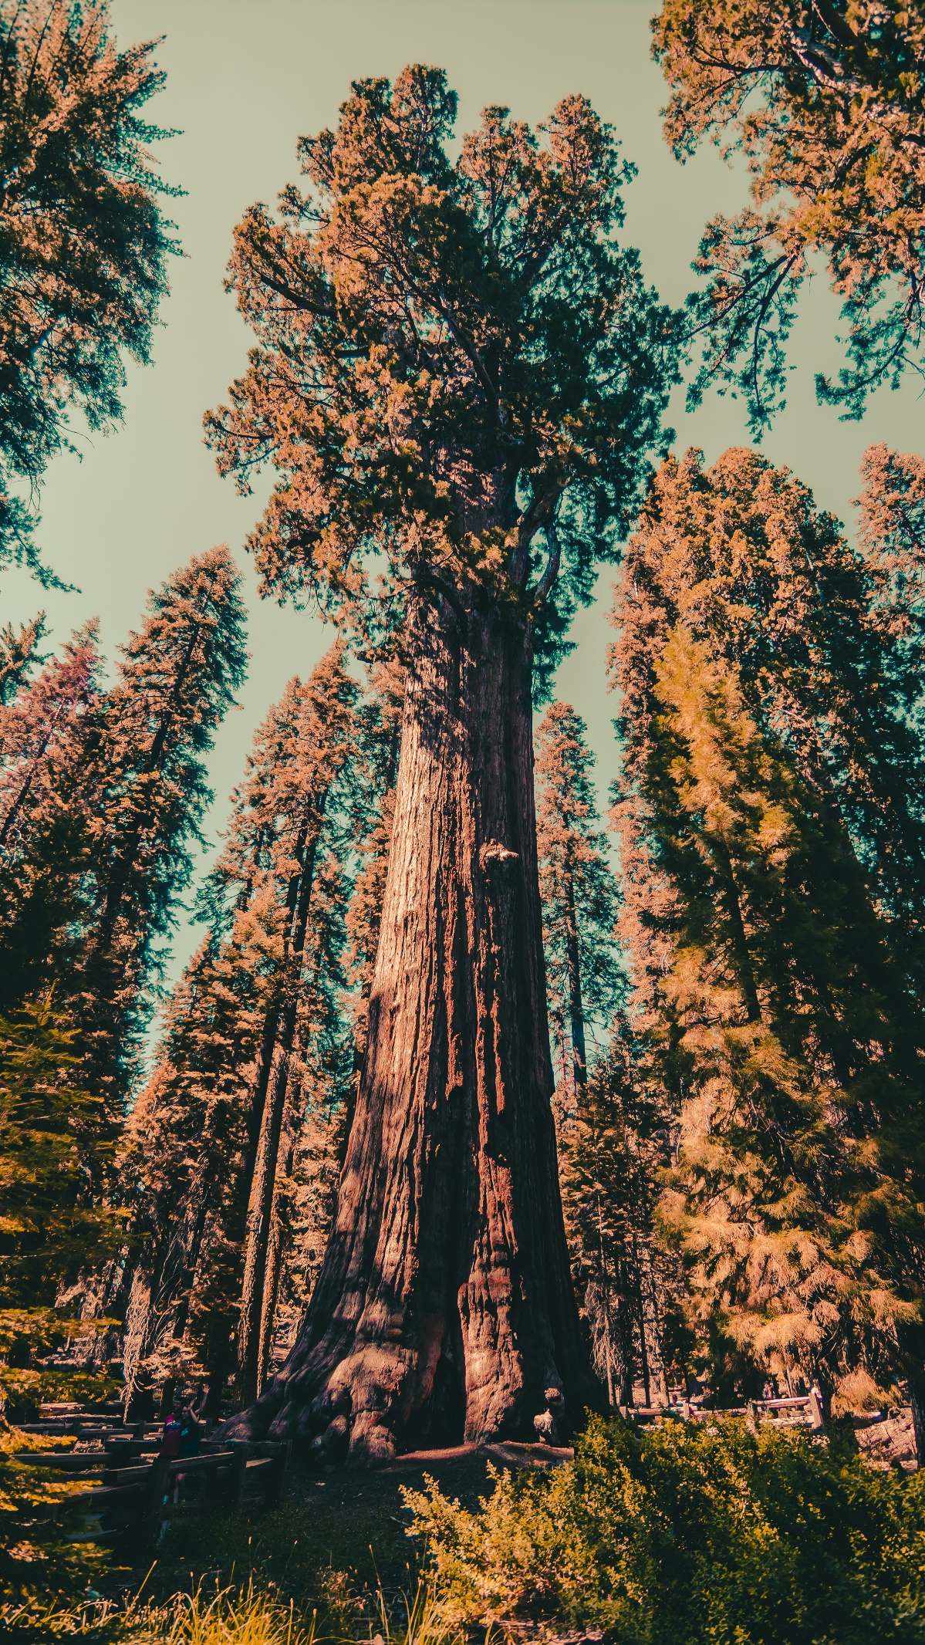

(Lizardo, 2016)

Further inspiration was then derived from the open world area of the Frostback Basin, as featured in the Jaws of Hakkon DLC of Dragon Age Inquisition (Bioware, 2015). This area features incredibly tall trees similar to the aforementioned redwoods, as well as treehouse like camps across various points of the map that serve as inspiration for the buildings used by the elves in Titan’s Rest. In addition, Frostback Basin features high levels of terrain verticality, a point which was also taken into consideration for Titan’s Rest to add more variety to traversal of this area.

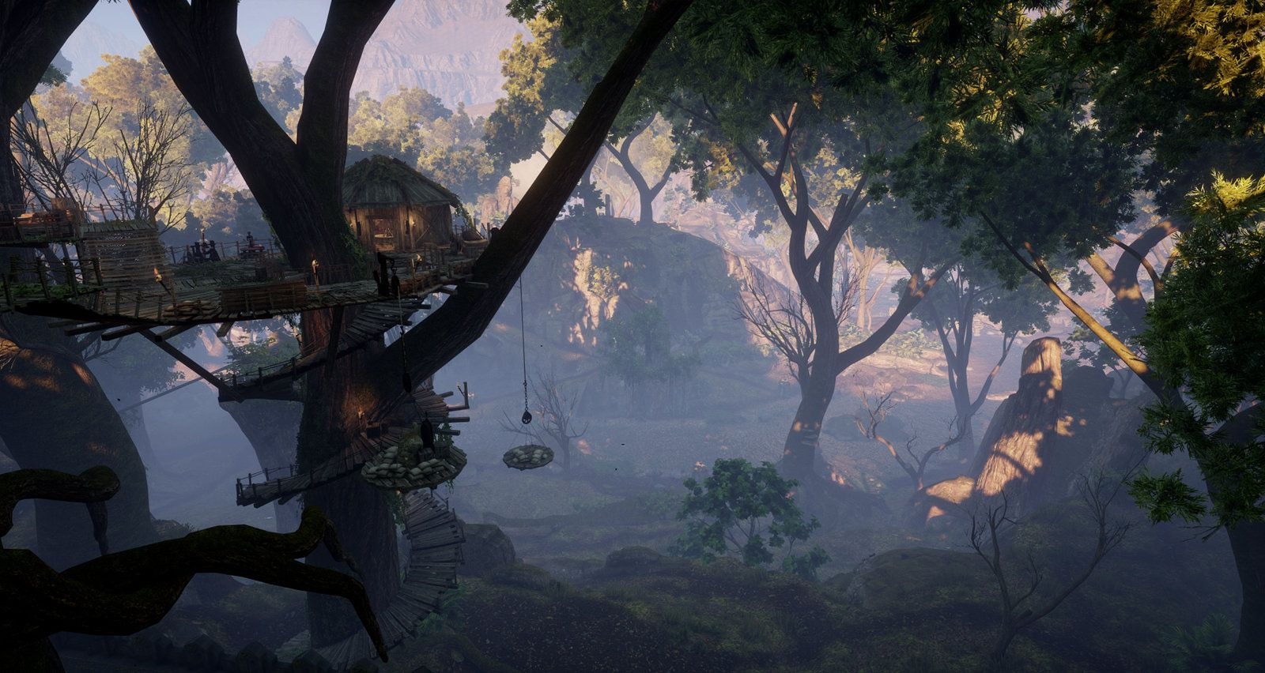

(Frostback Basin, Dragon Age: Inquisition, Bioware, 2015)

The inclusion of the unnaturally large fauna wandering through this land is inspired by the Studio Ghibli animated film Princess Mononoke (Studio Ghibli, 1997), which centres its story around a magical forest filled with giant wildlife.

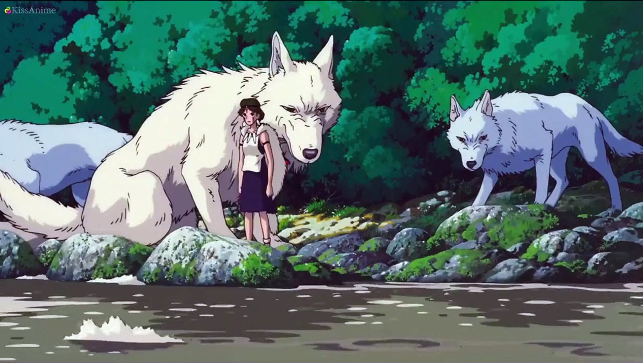

(Princess Mononoke, 1997)

### 2.3.7. Scorching Marshes

A significant point of reference for the inspiration of the Scorching Marshes was the explorable swamp area on the outskirts of Vizima in the first Witcher game (CD Projekt Red, 2007), due to its deeply foreboding atmosphere created through thick, unnaturally coloured fog, unsettling atmospheric music, and frequently occurring deadly enemies and environmental hazards.

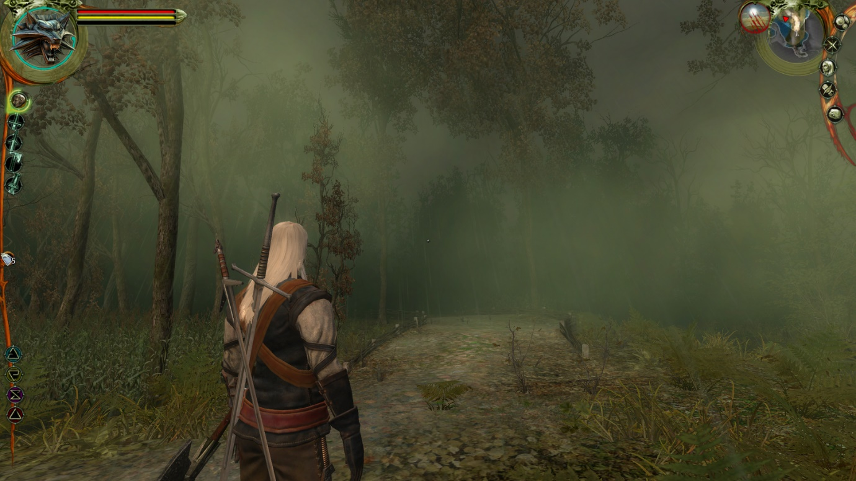

(Swamp, The Witcher, CD Projekt Red, 2007)

### 2.3.8. Land of Unending Flux

As this land is under constant change and chaos due to the opposing natural and unnatural forces of the surrounding lands on all sides of it, elements of the aesthetic design for this area will be taken from each of these surrounding areas, but a large inspiration for the aesthetics of this area is also from the concept of a No Man’s Land that has been left decimated by the effects of a previously fought war. The land had been entirely dominated and destroyed by outside forces and is now left in a state of ruin which will change overtime, a concept which provided clear inspiration for this constantly changing land always under intense pressure and chaos from the opposing forces of the lands surrounding it in Ewa.

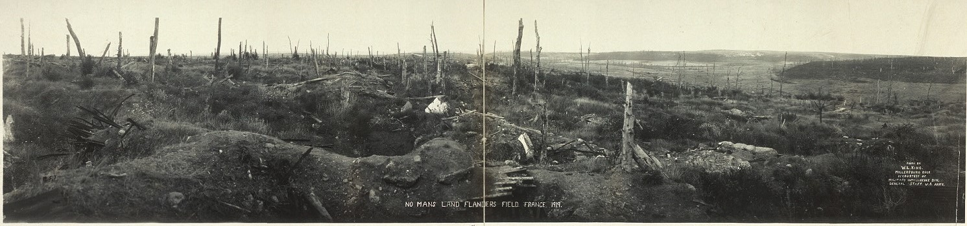

(W. L. King, 1919)

### 2.3.9. The Sunder

Due to the otherworldly nature of The Sunder, inspiration was taken from a number of varied sources to inspire its aesthetic design in order to make this land feel mysterious and alien. The idea of the land consisting of a piece of an alien planet that had broken off and collided with the world took partial inspiration from the fractured design of the planet Lola Sayu as featured in Star Wars: The Clone Wars (‘The Citadel’, 2011). In terms of the design of the landscape itself that would be found in The Sunder, inspiration was taken from the visuals of the 3D platformer game Fe (Zoink, 2017), which features a world dense with magical atmosphere.

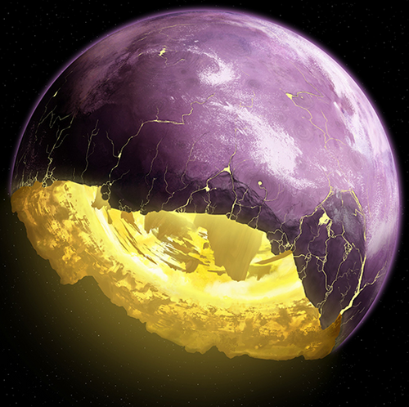

(The planet of Lola Sayu, ‘The Citadel’, Star Wars: The Clone Wars, 2011)

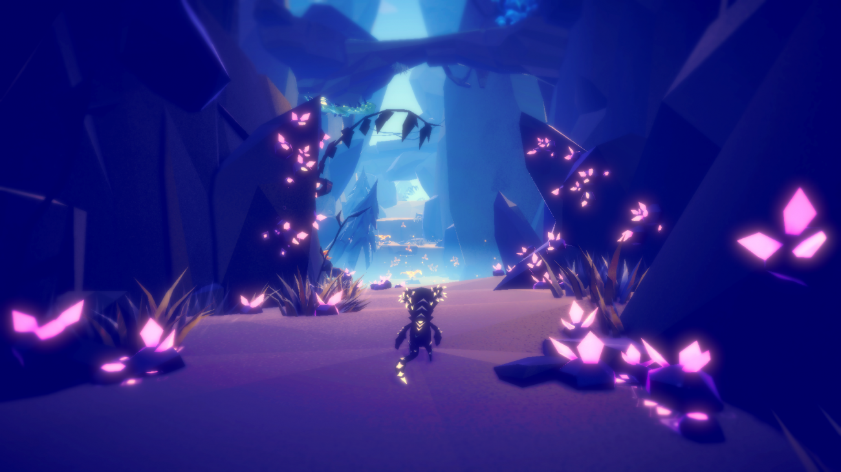

(Fe, Zoink, 2017)

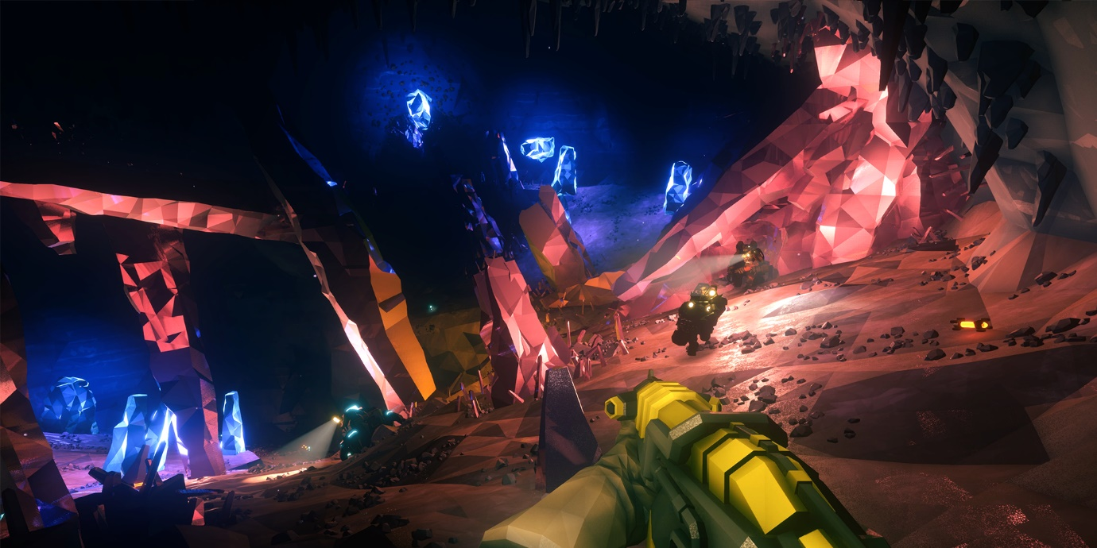

(Deep Rock Galactic, Ghost Ship Games, 2020)

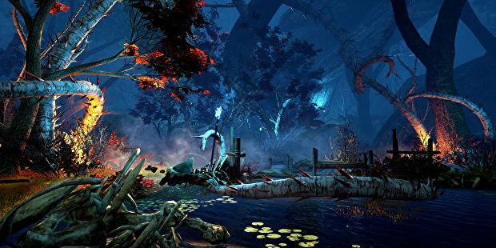

(Frostback Basin Swamp, Dragon Age: Inquisition, Bioware, 2015)

### 2.3.10. Lost Cities of the Śima

The cities of the Śima take heavy inspiration from the Dark Crystal – including the original movie (The Dark Crystal, 1982), and the recently released Netflix prequel series (The Dark Crystal: Age of Resistance, 2019). This is due to the incredibly creative, visually striking, otherworldly architecture style designed for use in this high fantasy series, which provides a perfect point of reference for the mysterious ancient civilisation of the Śima.

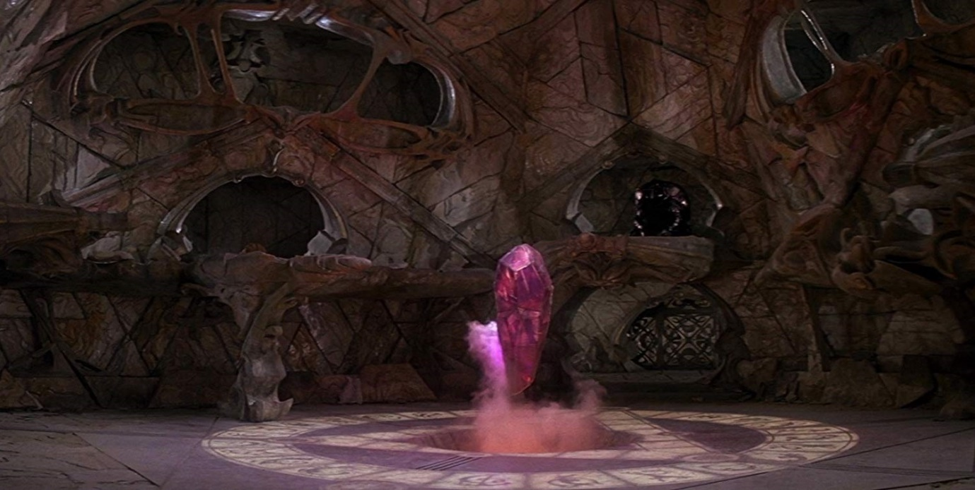

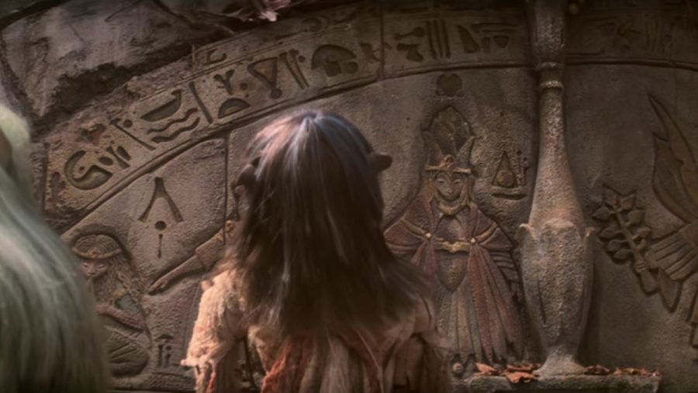

(The Dark Crystal, 1982)

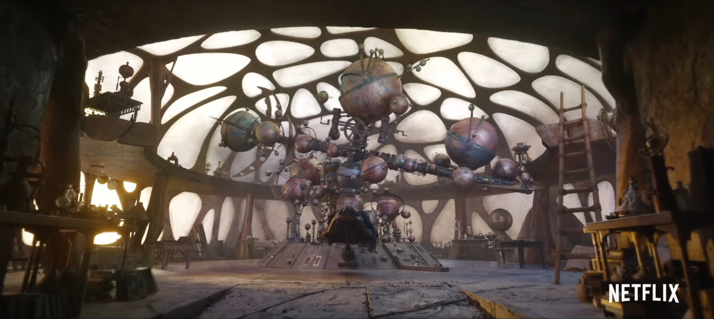

(The Dark Crystal: Age of Resistance, 2019)

# 3. Combat and Enemies

## 3.1. Combat System

### 3.1.1. Overview

The combat system is primarily composed of two forms of combat: traditional VR melee and ranged combat and spell casting. The method for casting spells is detailed thoroughly below in the magic system section of the design document however the general ideas and damage will be discussed here but the traditional combat will be fully explained below. Due to the game being virtual reality the player will have direct control over character movement which includes swinging melee weapons, blocking with shields, firing arrows and casting spells. Each weapon has strengths and weaknesses based on size, damage value and damage type and weapons will improve with progression throughout the game to encourage the user to explore a wide variety of weapons and weapon types with the most advanced and powerful weapons being tied directly to progression through the main objectives and exploration in the later game areas.

The player will be able to freely move during combat via the thumbstick which will allow for the player to manoeuvre around many enemies, use features of the environment for cover and will allow the player to retreat if a fight seems too difficult for their current progression or skill level. Furthermore, different enemy types will be weak or resistant to both certain weapon types and elemental affinities encouraging the player to use a variety of different weapons for varied purposes throughout their playthrough. Spells use a complex system of runes to cast which is activated via a keybind but can be used during combat allowing the player to swiftly move between traditional combat and casting to give the player more variety in combat. Weapons can also be enhanced by magic with ability to enchant weapons and arrows with elemental damage allowing them to deal more damage to the opposing element but reduced damage to its own element meaning the player must be careful with which element they choose or swap often to maximise their damage.

### 3.1.2. Melee Combat

Melee combat is done via the VR controllers, each controller representing one hand that can be used to hold an object or weapon. By holding a button on the VR controller the player is able to grip the weapon(s) with some allowing for two handed grips such as swords, maces and bows whereas some smaller weapons such as daggers are exclusively used in one hand but allowing the player to move faster and reposition around their enemy. Melee weapons are swung physically by the player and have different damage, movement speed and range meaning each weapon excels against different enemies present in the game. Also, due to the game being VR it is important that the player have a choice in different weapons as they may dislike the way a certain weapon feels physically to them which would significantly reduce their enjoyment of the game if they could not swap.

Shields are also present allowing for the player to physically block weapons and projectiles and close the distance to more passive ranged enemies if used correctly. They can be used with the majority of melee weapons as well which will allow the player to fight more aggressively if they are able to block well. This range of weapons added to the ability to wield a shield allows for players to have a range of experiences depending on the weapons they choose to equip and mould their character to the play style they prefer without needing a skill tree or other traditional methods of character alteration.

### 3.1.3. Ranged Combat

Ranged combat is made up of two parts, traditional ranged weapons and spell casting. Spell casting is covered in the magic system part of the brief in far more detail so only the traditional ranged combat will be covered here. The player must use one controller to grip the bow and the other to set an arrow into the strings which can then be drawn with the arrow hand. There is a degree of aim assistance as VR is notoriously difficult to aim so to prevent frustration from the player the bow will centre itself near to a target when they draw it back, so they only need to do minor adjustments. Arrows also gain the sharp damage type increasing their damage against unarmoured foes which incentivises using them in the rural areas against animal type enemies just as they were designed for originally. Furthermore, bows can also be enchanted the same as melee weapons allowing them to be an effective weapon against the magical creatures of the world. For ease of use the player will also be able to simply press a button whilst wielding a bow to load it automatically but they will still have to aim and fire it themselves.

## 3.2. Weaponry

3.2.1. Melee Weapons

Traditional weaponry is split into two categories, sharp and blunt weapons. Sharp weaponry is all melee weapons with a blade such as a longsword, katana and a dagger, and does more damage to enemies without armour but slightly reduced damage to armoured targets. On the other hand, blunt weapons are the non bladed melee weapons such as a warhammer, mace and a flail which deal more damage to armoured opponents but slightly reduced damage to unarmoured targets. The range of melee weapons present in the game is extensive, containing the majority of significant historical weaponry from all eras of human history. Here is a list of a majority of them:

* Longsword
* Shortsword
* Katana
* Wakizashi
* Spear
* Dagger
* Cutlass
* Mace
* Warhammer
* Flail

Each of these weapon types has multiple versions in-game that become more elaborate and effective as the game progresses. However, the range of weaponry and inherent strengths and weaknesses of each encourages the player to swap weapons often to best match the foe they are facing. Shields are also present in different sizes allowing the player to block conventional weapons and projectiles but being almost useless against magic.

### 3.2.2. Ranged Weapons

Ranged weapons contain a variety of bows which have different damage values and draw lengths. Draw length will determine how far the player needs to pull back the bow to fire which will affect how fast the player will be able to fire as it will not fire if it is not to draw length. The bows will generally fit into three categories:

* Shortbows
* Standard Bows
* Longbows

This will directly reflect the draw length with short bows being the lowest draw length but also having generally lower damage than their larger counterparts. This will allow the player a choice that best suits their play style and in-game circumstances. An example of a standard bow is shown below:

Bow of Snakes

An intricately carved bow, it is said the strings bite the wielder with use.

Damage: 4

Damage Type: Sharp

Draw Length: Medium

Ammo Type: Arrow

.

(Elden Ring, 2022)

### 3.2.3. Staffs

Staffs are only a small part of the magic system and the main variety with magic comes through runes. However, there are still a number of different staffs that boost the damage of the element associated with that staff. For example, here I will display the detailed description for the light elemental staff:

The Staff of Eternal Starlight:

It is said that the staff itself once contained the power of a star but now it only emanates a faint glow. This staff gives a 25% damage bonus to any spell that contains a light rune. The staffs are rare items and only one exists per element, but they will generally be along the path of the main story allowing the player a high chance to find them. However, this staff also decreases the damage of any spell cast containing a shadow rune by 10%.

(The Lord of the Rings: The Two Towers, 2002)

### 3.2.4. Śima Weaponry

The Śima are the race of beings who lived in the lands of the game in an era before the player experiences it, they are extinct, but their technology is still hidden within their cities which the player explores late into the game. There is a Śima weapon for each style of weapon displayed earlier and they are the most powerful weapon in their class which is balanced by requiring the player to explore deep into the end game cities to find these weapons. They will also be protected by powerful magical enemies that are drawn to the weapons due to their latent energy. An example of a Śima weapon can be seen here:

Sword of the Forebearers:

The lost technology of the Śima, lost to time no longer.

Damage: 10

Damage Type: Sharp

(Valorant, 2020)

## 3.3. Damage Calculations

The damage calculations are relatively simple for combat as there is only a small number of factors that need to be used. For traditional weaponry the calculation would be:

((Character Strength + Weapon Damage) * Blunt/ Sharp Weapon * Elemental Enhancement) - Enemy Defence = Damage Output

Whereas for magic it would be:

Spell Damage * Staff Enhancement = Damage Output

Each of the elemental damage types and their bonuses for traditional weapons can be seen in this table with the enemy element being on top and the elemental enhancement for the weapon down the left:

|  |  |  |  |  |  |  |
| --- | --- | --- | --- | --- | --- | --- |
|  | Fire | Water | Wind | Earth | Light | Shadow |
| Fire | 1.0x | 0.9x | 1.0x | 1.25x | 1.0x | 1.0x |
| Water | 1.25x | 1.0x | 0.9x | 1.0x | 1.0x | 1.0x |
| Wind | 1.0x | 1.25x | 1.0x | 0.9x | 1.0x | 1.0x |
| Earth | 0.9x | 1.0x | 1.25x | 1.0x | 1.0x | 1.0x |
| Light | 1.0x | 1.0x | 1.0x | 1.0x | 0.75x | 1.25x |
| Shadow | 1.0x | 1.0x | 1.0x | 1.0x | 1.25x | 0.75x |

## 3.4. Enemies

### 3.4.1. Overview

There is a wide variety of enemies in the game however, they can widely fit into three categories: human enemies, animal/ natural enemies and magical enemies. Human enemies are self explanatory and are the most common form of enemy that will be encountered on the road by the player in the form of bandits and city guards. The animals and nature are also working against the player becoming increasingly corrupted by magic as the game progresses allowing them to grow in power and aggression as the player ventures into the farther lands. These farther lands are also where the player will encounter pure magical enemies, these are only able to exist in places of high magical energy and as such are concentrated to the late game areas due to their focus on magic. They are able to cast spells at the player without the use of runes and are often small and fast allowing them to outmanoeuvre the player if they aren’t fast.

### 3.4.2. Human Enemies

Human enemies come in a wide variety of forms but wield the same weapons that the player has access to throughout their playthrough. They often fall under the umbrella of either thieves, bandits or mercenaries; however, within these classifications there are distinct visual differences to set certain factions apart and allow the player to recognise the power of an opponent at a glance. As the player progresses through the game, they will encounter fewer human enemies as many would not dare venture into some of the lands that the magic corruption has more control over. They will also congregate towards settlements meaning the player will often have to pass bandits to get to a safe area. An example enemy is shown below:

A Knight of the Exalted Principality

These knights belong to the city of the Exalted Principality where they act as law keepers and city guards. They protect the monarch despite the clear corruption he has brought to the city under his rule they still protect the crown as they are sworn to. These knights can have a variety of weapons but are always seen with a shield and full armour. Some have left the city and now act as bandit leaders and mercenaries across the world as they refuse to serve the king and would rather make a life for themselves independent of the kingdom.

Damage: 5

Defence: 8 (Armoured)

Movement Speed: Slow

Attack Speed: Slow

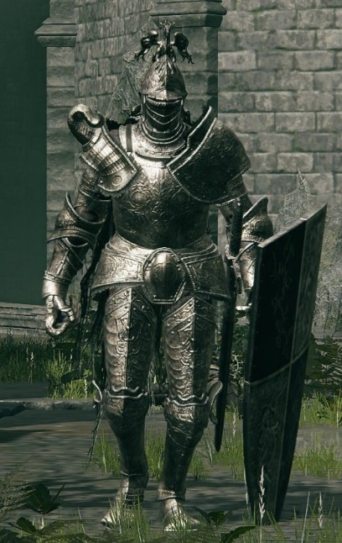

(Elden Ring, 2022)

3.4.3. Animal/ Natural Enemies

The animals and plants of Ewa are mostly passive creatures; however, the magical corruption of the world has begun to drive them to violence against both each other and people. The more corrupted amongst them have been grotesquely mutilated growing extra claws and appendages and have become more aggressive. A number of the animals that are present are bears, wolves, stags and birds each having different sizes and stats. A number of the plants of Ewa are also sentient and patrol the wilds trying to keep balance in the natural world and prevent destruction of the natural world. Whilst animals are common throughout the world natural enemies are far less common but often larger and more imposing. An example enemy is shown below:

Treant Hound

The treant hound is a form of treant that walks on all fours. They are a natural creature but are also magically attuned to earth due to their inherent natural qualities. They are passive creatures unless they are attacked or have been corrupted by the magic of their surroundings turning them into a creature to be feared.

Damage: 7

Defence: 5 (Unarmoured)

Movement Speed: Slow

Attack Speed: Slow

Magical Affinity: Earth

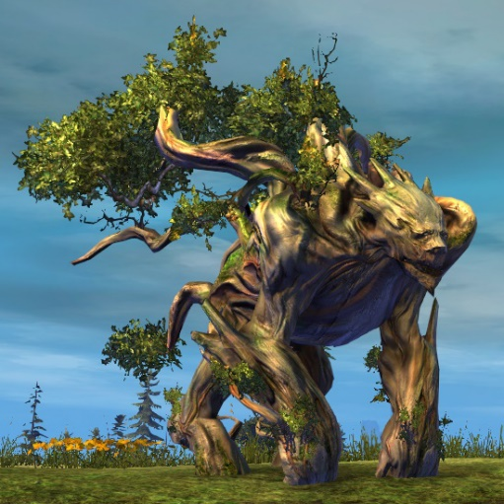

(Guild Wars 2, 2012)

### 3.4.4. Magical Enemies

Since The Sunder crashed into Ewa magical creatures have begun to appear more frequently throughout the world being able to transform between physical forms and pure energy. They are concentrated in magical areas of the world such as the cities of the Śima and The Sunder and have complete control over a specific element of magic. Their physical forms can take damage but are also more powerful spell casters and are more powerful the closer they are to a centre of magic. Their physical forms often resemble bird like creatures each coloured to match its element and adorned with a magical aura. An example of one can be seen below:

Firehawk

The firehawk is the most common form of fire magical creature resembling a phoenix somewhat but with only a flaming lower and humanoid arms and hands. These creatures become more fiery the more powerful they are with the most powerful being almost completely fire somewhere between its energetic form and its physical form. It is also able to physically attack the player with its beak and can hold weapons although it is uncommon for them to do so.

Damage: 8

Defence: 6 (Unarmoured)

Movement Speed: Fast

Attack Speed: Medium

Magical Affinity: Fire

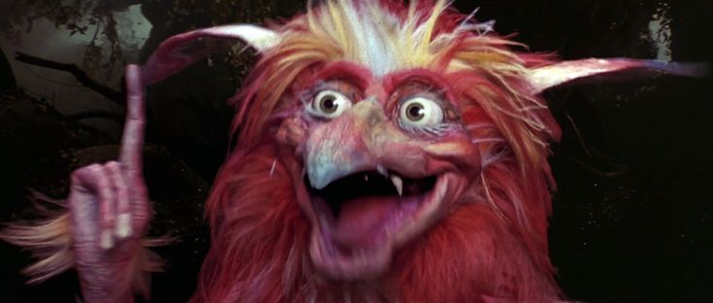

(Labyrinth, 1986)

### 3.4.5. Bosses

The majority of the bosses in the game are stronger, larger and more aggressive versions of each of the previously mentioned enemy types. They are renowned warriors or bandits, highly corrupted animals or plants and the greatest of the magical enemies who are often found at the focal points of magic corruption. The human bosses will have a variety of weapons, often having access to more powerful weapons than standard enemies and magic later in the game's progression. They also have higher health and defence than average enemies wearing distinct clothes or armour to stand out from the standard enemy types. The natural bosses are further corrupted beyond a normal level growing in size and aggression and leaking magical energies from their bodies that they have absorbed from the surrounding corruption. These will often be based on the strongest natural enemies such as giant bears, treants and basilisks. Finally, the last generic type of boss will be magical creatures, empowered by being so close to the source of magical corruption they grow in size and power casting magical energies into the world around them with their attacks being specific to their elemental type and the area around them representing this.

Two unique bosses are The Devourer and Tory, The Devourer is the standard final boss of the game however due to its colossal size it cannot be defeated by traditional means and the player but go inside the creature, fighting magical enemies and minor bosses as they progress towards the head of the creature in an attempt to find a way to defeat or subdue it. However, despite its appearance as a planet devouring creature of pure magic the devourer is actually intelligent allowing the player the choice to stab the creature in its brain and kill it or to reason with it and preserve the cosmic balance that such a creature would be fundamental in preserving. Regardless of the player's choice the world is now safe and with the magical corruption mostly gone it can start to repair itself. This is where Tory appears as the secret final boss if the player is of a sufficient level. Tory is unique as she was a previously met NPC that was the barkeeper at the ever-present weathered spoon taverns that appeared throughout the world offering the player advice and items for currency. It is revealed Tory is a being of god-like power known as a wisp and this is her form of tribute that the player has unknowingly contributed to throughout the game. Her power is directly scaled to how much the player has given her throughout their playthrough meaning she can be incredibly powerful due directly to the player's actions in the world.

# 4. Magic System

There are a great many spells in this world. Many are known by any magi worth their salt, yet many more remain hidden. Lost to the passage of time, these all powerful magics are said to bring to the land great prosperity…  
…or destruction.

## 4.0. Key Words and Legend

This section makes use of abbreviations to show different values. What follows is a table of these abbreviations and their meaning.

|  |  |
| --- | --- |
| **Abbreviation** | **Meaning** |
| hp | Health Points |
| mp | Mana Points |
| (no)s | (Number of) Seconds |
| /s | Per Second |
| m | Meters |

## 4.1. Casting Method

In {GAME NAME}, there are two methods or modes for casting spells: Drawing Mode and Quick Select Mode.

In Quick Select Mode the player brings up the radial rune menu (see 1.6.3. Controls) and selects a rune using the cursor (Mouse/Joystick).

In Drawing Mode, the player brings up the casting template (see controls.), which appears around the cursor. With the casting template visible, the player positions their cursor, holds the draw key (see controls.), and draws the rune themselves. Accuracy is key in this mode, as the further the drawn rune is to the pre-set runes (see Solo Runes.) the lower the damage modifier will be.

In both modes, time is slowed down by 90% as the player prepares their spell to give them enough time to plan out their actions.

## 4.2. Mana

Mana is the primary resource for casting spells, it accumulates over time until the player’s mana bar has reached capacity. The base capacity for mana is 100mp, but the total amount of mana accessible to the player can be increased beyond this value through the use of magical artifacts (See 4.3. Magical Artifacts.)

### 4.2.1. Gaining Mana

#### 4.2.1.1. Mana Generation in Combat

The player does not generate any mana whilst they are casting, and for 2 seconds after casting. This ensures the player does not abuse the slowing of time whilst casting to regenerate their mana. The conditions for generating mana during combat are as follows:  
1. Player is not currently casting  
2. Two Seconds passed since last cast.

With these conditions met, the player will begin to generate mana at a rate of 20mp/3s.

#### 4.2.1.2. Mana Generation out of Combat

When not in combat, mana is generated at a rate of 10mp/s and mana stored in un-aspected crystals within the players’ inventory refills the player’s mana at a rate of 1mp/s.

#### 4.2.1.3. Mana Generation Boosters

Around the world are scattered crystals, reservoirs of mana, being close to one of these crystals increases the rate at which the player generates mana in combat to 25mp/2s and removes the need to wait 2 seconds after the previous cast.

#### 4.2.1.4. Mana Generation Halters

These crystals, however, are also used by the other entities – both docile and hostile – surrounding it. When a hostile creature is generating mana from a crystal, the player is unable to gain mana from the same source. In order to generate mana from such a crystal, the hostile entity must be removed from the range of the crystal.

#### 4.2.1.5. Mana Types (Aspects)

Mana comes in many types, known as Aspects. Fire, Water, Wind, Earth, Light, Shadow, Ancient. These aspects modify the mana consumption of spells of the same type (See 4.2.2. Spending Mana.) Mana that has none of these types is called un-aspected mana.

### 4.2.2. Spending Mana

#### 4.2.2.1 Mana Cost Calculation for Spells

The amount of mana spent per cast depends on multiple factors.

* Rune Level
* Aspected Mana
* Spell Stage

Rune Level refers to whether a rune is basic, intermediate, or advanced, requiring 10, 15, and 20mp respectively.  
If the player has mana in their mana pool which is of the same aspect as the rune they just drew, the mana cost for that rune is reduced to 2/3rds (**round up** to nearest whole number) of its usual cost.  
Aspected mana is used automatically if the player has enough of it to cast their spell.  
Should the player attempt to cast a spell costing more mana that they currently have, the spell will fail, and no mana will be lost.  
If the player draws two runes, advancing the spell stage to Duo, the total mana cost is multiplied by 1.5x  
If the player draws three runes, advancing the spell stage to Tri, the total mana cost is multiplied by 2x  
The rune stage mana cost multipliers **do not stack,** the cost is either multiplied by **1.5x OR 2x**  
  
**Spells cast first check the player’s own mana for the same aspect, then check the player’s Mana-Bearing Crystals (see** 4.3.1. Mana-Bearing Crystals). If enough mana of the same aspect is not found, the spell instead looks back to the player’s mana for mana types in this order: Un-Aspected, Fire, Water, Wind, Earth, Light, Shadow, Ancient. Finally, if the player hasn’t enough mana, the spell will take from the crystals in their inventory using the same order.

#### 4.2.2.2. Examples For Mana Cost Calculation

**Example 1,** player draws a single basic rune, with same-aspected mana (10x0.66=6.6=**7mp**).This is a Single Stage spell, so no multiplier is applied, leaving the total cost at **7mp**.

**Example 2,** player draws a basic rune (**10mp**) with un-aspected mana and continues to draw an advanced rune with mana of the same aspect (20x0.66=13.2=**14mp**). The total so far is 24mp, but because the spell stage is Duo this must be multiplied by 1.5x (24x1.5=**36mp**) making the spell cost **36mp**.

**Example 3**, player draws three intermediate runes in sequence, each with same-aspected mana (15x0.66=9.9=10, 10x3=**30mp**). This is a Tri Stage spell, so it’s cost must be multiplied by 2x (30x2=**60mp**) for a total cost of **60mp.**

**Example 4,** player draws two advanced runes, one with same-aspected mana (20x0.66=13.2=**14mp**) and one without (**20mp**), and a single intermediate rune without same-aspected mana (**15mp**). This is a Tri Stage rune, so multiply the total by 2x to get the cost of **98mp.**

## 4.3. Magical Artifacts

### 4.3.1. Mana-Bearing Crystals

There are items called Mana-Bearing Crystals which can hold mana that the player generates over their current mp capacity, allowing the player the ability to store additional mana to use in their spells. The crystals come in different aspects, following the list of mana types, and a crystal of a specific aspect can only be used to store mana of the same aspect. Non-aspected crystals are also available, any mana stored within is converted to non-aspected mana.

All Mana-Bearing Crystals – regardless of their aspect – can hold up to 100mp.  
As with the player’s own mana, spells cast will attempt to take mana of the same aspect from crystals, but not before checking the player’s own mana.

## 4.4. Enchanting Weapons

The player can apply basic runes to their weapons by way of enchanting. This action takes the standard amount of mana for casting a single basic rune and gives the weapon higher damage against enemies weak to the aspect of the magic. As an example, the player enchants their sword with the aspect of fire, this costs them 10mp, and the weapon is now more affective against earth-aspected enemies whilst being weaker against water-aspected enemies. For details on the damage modifiers, see [HYPERLINK ME ->] Weapons and Combat – Enchanted Weaponry.

Players may re-enchant their weapon at any time if they have enough mana, a weapons enchantment can be removed by infusing it with unaspected mana.

To enchant a weapon, the player must move to the enchanting menu (See 1.6. Interface Design). In this menu the player selects their weapon and the enchantment aspect, they are shown the mana cost and press the enchant button.

## 4.5. Obtaining Runes and Learning Spells

Runes are obtained by various means. They are found engraved into stone tablets in ancient ruins, traded for in towns, and taught by fellow magic-users throughout the world.  
Learning spells requires the player to experiment with combing runes, or to have seen the spell be cast by another magic-user. Once a player has learned a spell, it will appear in their spell book along with the runes used to create it, the standard mana cost, and a description of the spell’s effects.

## 4.6. Runes

|  |  |
| --- | --- |
| * Fire Damage Rune - Basic Fireball: Shoots forward from player position. +Burn: May set target aflame, dealing fire-aspected damage over time. Base Damage: 5hp Effect Chance: 15%, Effect Damage: 2/s, Effect Duration: 5s |  |
| * Combustion Damage Rune – Intermediate |  |
| * Eruption Damage Rune – Advanced |  |
| * Water Slowing Rune - Basic Drench: Soaks the target, lowering their movement speed. +Chill: May freeze the target, disabling their movement and attack for a short time.  Base Damage: 1hp, Movement Speed: -30% Effect Chance: 10%, Effect Duration: 3s |  |
| * Torrent Slowing Rune – Intermediate |  |
| * Flood Slowing Rune – Advanced |  |
| * Wind Knockback/Area of Effect Rune - Basic Gust: A sharp gust of wind, knocks enemies back.  +Slice: May cut the target, causing bleed damage over time. Base Damage: 2hp, Knockback: 3m Effect Chance: 10%, Effect Damage: 1/s, Effect Duration: 10s |  |
| * Tornado Knockback/Area of Effect Rune - Intermediate |  |
| * Storm Knockback/Area of Effect Rune – Advanced |  |
| * Earth Defence Rune - Basic Wall: Erect a wall of earth at the target position, blocking enemy advancement.  Base Damage: 0hp Effect Duration: 5s |  |
| * Bastion Defence Rune - Intermediate Armour: Applies armour to caster, reducing damage taken  Damage Resisted: 25% Duration: 30s |  |
| * Quake Defence Rune – Advanced |  |
| * Light Healing Rune - Basic Cure: Restores Health Points. +Blessing: May cast twice. Base Healing: 25hp Additional Effect Chance: 15% |  |
| * Glare Healing Rune – Intermediate |  |
| * Blind Healing Rune – Advanced |  |
| * Shadow Curse Rune - Basic Curse: Temporarily increase target’s damage taken. +Enfeeble: May remove enemy target’s bonus effect. Increases Base Damage by +20% Additional Effect Chance: 25%, Effect Duration: 30s |  |
| * Void Curse Rune – Intermediate |  |
| * Abyss Curse Rune – Advanced |  |
| * Ancient Forgotten/Chaotic Rune - Basic Potential: Unlocks the true potential of another rune, boosting its additional effect chance. -Fizzle: Chance to cause the spell to fail, mana is still lost. Base Damage: 0hp, Boost Effect Chance By: 20% Additional Effect Chance: 33% |  |
| * Corrupt Forgotten/Chaotic Rune – Intermediate |  |
| * Enigma Forgotten/Chaotic Rune – Advanced |  |

## 4.7. Example Spells

|  |  |
| --- | --- |
| * Cutting Flame (Wind + Fire) Spell - Basic A hot gust of wind batters the area, causing damage to all within its range and knocking them back. Base Damage: 8hp |  |
| * Light Armour (Bastion + Light) Spell - Intermediate Grants the caster light-aspected armour, absorbing damage from light-aspected sources. Light Damage Resisted: 50% Duration: 30s |  |
| * The End of Days (Ancient + Corrupt + Enigma) A fate not unlike that once faced by our forebears Spell – Advanced A random nearby entity (Enemy, Player, Passive creature, NPC) is erased from existence. The erased entity leaves nothing behind. Does not affect Boss Enemies or entities required for progression. Drains ALL mana held by the player, including that within mana-bearing crystals. If the player is unfortunate enough to be erased from existence, they must load their previous save data (and pray they don’t make the same mistake again). |  |

## 4.8 Spell Effectiveness

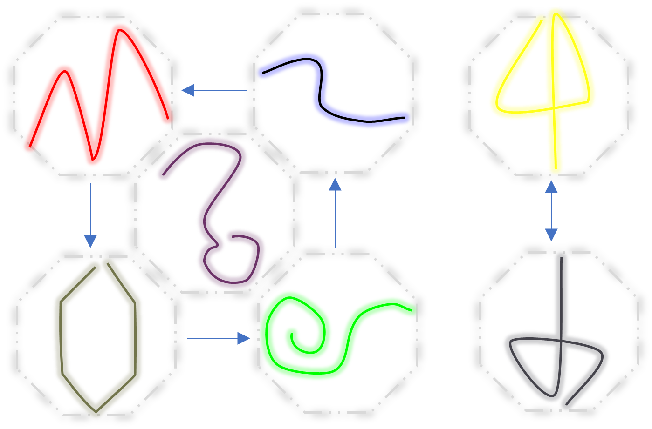

# 5. Reference List

1. ArenaNet. (2012) Guild Wars 2 [Video Game]. *NCSoft.*
2. Avalanche Studios. (2015) Mad Max [Video Game]. *Warner Bros. Interactive Entertainment*.
3. Bethesda Game Studios (2011) The Elder Scrolls V: Skyrim [Video Game]. *Bethesda Softworks.*
4. Bethesda Game Studios. (2006) The Elder Scrolls IV: Oblivion [Video Game]. *Bethesda Softworks.*
5. Bethesda Game Studios. (2017) Fallout 4 VR [Video Game]. *Bethesda Softworks.*
6. Billings, J. (2020) The standard shot… Available at: <https://www.photohound.co/i/aira-force-high-forces-lake-district-1015706>
7. Bioware. (2015) Dragon Age: Inquisition [Video Game]. *Electronic Arts*.
8. CD Projekt Red. (2007) The Witcher [Video Game]. *Atari*.
9. CD Projekt Red. (2015) The Witcher 3: Wild Hunt [Video Game]. *CD Projekt.*
10. FromSoftware. (2022) Elden Ring [Video Game]. *Bandai Namco Entertainment.*
11. Ghost Ship Games. (2020) Deep Rock Galactic [Video Game]. *Coffee Stain Publishing*.
12. Iron Gate Studio. (2021) Valheim [Video Game]. *Coffee Stain Publishing.*
13. King, W. L. (1919) No Mans Land, Flanders Field, France, 1919. Available at: <https://artsandculture.google.com/asset/no-mans-land-flanders-field-france-1919-w-l-king/kAExOTTMt4jCRw?hl=en>
14. Kreuzschnabel. (2015) Swaledale. Available at: <https://commons.wikimedia.org/w/index.php?curid=46048805>
15. Lizardo, B. (2019) General Sherman Sequoia tree. Available at: <https://unsplash.com/photos/AhsP7Xj-9Dk>
16. Labyrinth (1986) Directed by J. Henson. [Feature Film]. Burbank, CA: TriStar Pictures, Inc.
17. Lord of the Rings: The Rings of Power (2022) Amazon Studios, New Line Cinema. Available at: Amazon Prime Video
18. Nintendo EPD. (2017) The Legend of Zelda: Breath of the Wild [Video Game]. *Nintendo*. Available at: <https://www.nintendo.co.uk/Games/Nintendo-Switch-games/The-Legend-of-Zelda-Breath-of-the-Wild-1173609.html>
19. Princess Mononoke (1997) Directed by H. Miyazaki. [Feature Film]. Koganei, Tokyo, Japan: Studio Ghibli Inc.
20. Riot Games. (2020) Valorant [Video Game]. *Riot Games.*
21. Robinson, M. (2016) Gordale waterfall – Malhamdale. Available at: <https://www.photohound.co/i/gordale-scar-and-janets-foss-13922>
22. Shelley, P. B. (1818) Ozymandias. *Gleeditions, Originally published in The Complete Poetical Works of Percy Bysshe Shelley, vol. 2, Oxford UP, 1914, pp. 546-49.* Available at: [www.gleeditions.com/ozymandias/students/pages.asp?lid=308&pg=4](http://www.gleeditions.com/ozymandias/students/pages.asp?lid=308&pg=4).
23. Square Enix Creative Business Unit III. (2013) Final Fantasy XIV: A Realm Reborn [Video Game]. *Square Enix.*
24. ‘The Citadel’. (2011) Star Wars: The Clone Wars, Season 3, Episode 18, *Cartoon Network*. 18 February.
25. The Dark Crystal (1982) Directed by J. Henson, F. Oz. [Feature Film]. Burbank, CA: New Line Cinema.
26. The Dark Crystal: Age of Resistance (2019) The Jim Henson Company. Available at: Netflix.
27. The Lord of the Rings: Fellowship of the Ring (2001) Directed by P. Jackson. [Feature Film]. Burbank, CA: New Line Cinema.
28. The Lord of the Rings: The Two Towers (2002) Peter Jackson [DVD] California: New Line Cinema
29. Zoink. (2018) Fe [Video Game]. *Electronic Arts*.